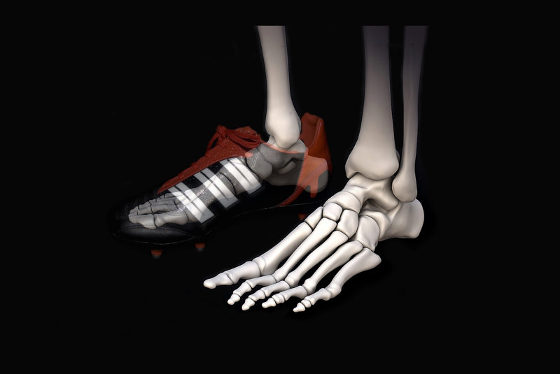Lecture 2 – Musculoskeletal Modelling in Physical Rehabilitation

Tibia

BONE ANATOMY OF THE ANKLE

Fibulala

* Shank, above the feet
  + Long and thick: tibia
  + Long and thin: fibula
* Views of the toes (phalanges) 🡪 most distal to the body:

Calcaneus

Talus

* + Medial: inside out (middle)
  + Lateral: Outside in (side)
  + Anterior: Front (Face on)
* Talus connects shank and foot together(bump on top of the foot)

Metatarsals

Phalanges

* Joints
  + True ankle joint is joint between talus and shank
    - If feet bends to ground: plantarflexion
    - If feet bends to sky: dorsiflexion
  + Subtalar joint is joint below talus
    - If right side of foot goes inwards: inversion
    - If right side of foot goes outwards: eversion
* Muscles
  + Moments 🡪 turning effect of force (**M** = **r** x **F**)
  + Plantarflexors
    - Over-branching name for triceps
    - Gastrocnemius cross both joints
    - Solems, when pushed up, causes calves to bend towards foot
  + Dorsiflexors pushes up on the calves causing it to be pushed back
  + Inverters rolls your ankle to either side
  + Evertors rolls your ankle outwards
  + Muscles that cause eversion that counteract inversion are called the peroneus muscle
* 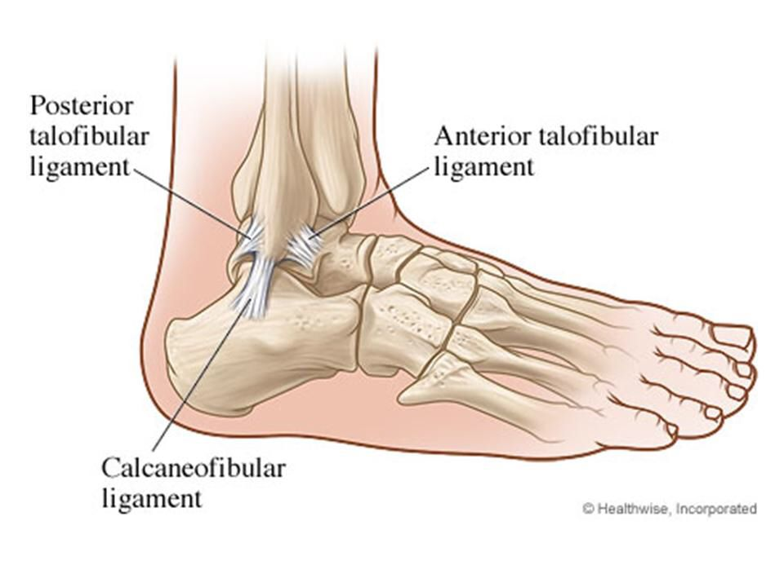Ligaments
  + Connect bone to bone
  + Important for joint stability
  + Important ligaments that contribute to injuries:
    - Anterior talofibular
    - Calcaneofibular
    - Posterior Talofibular
    - Anterior Tibiofibular (not focused for ankle injury) [green]

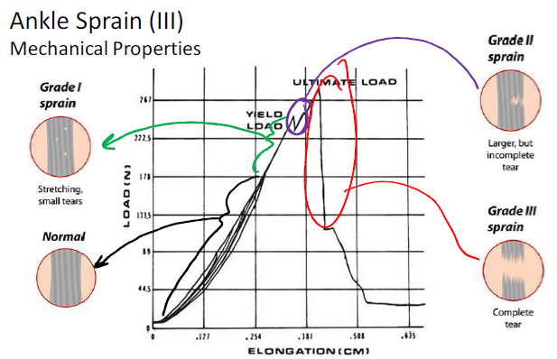ANKLE INJURIES

|  |  |
| --- | --- |
| **Structure** | **Injury** |
| Bone | Fracture, bruise |
| Ligament | Sprain |
| Muscle | Strain |
| Tendon | Tendinopathy |
| Cartilage | Tear |

* Ankle Sprains 🡪 anterior talofibular ligament
  + Grade 1: Stretchy, small tears
  + Grade 2: Large, but incomplete tear
  + Grade 3: Complete tear
* Ankle sprains risk factor
  + Previous or existing ankle injury (biggest factor)
  + Lack of strength, stability, flexibility in the ankle
  + Poor balance
  + Sudden acceleration and deceleration in direction
  + Increasing age
* Prevention of ankle sprains
  + Balance training
  + Ankle strengthening
  + Flexibility
  + Adequate preparation
  + Taping and bracing

|  |  |  |  |
| --- | --- | --- | --- |
| **Taping** | | **Braces** | |
| Pros | Cons | Pros | Cons |
| Customisable | Cost | Reusable | Uncomfortable |
| Less bulky | Qualified Person | Cost |  |
| Proprioception (sense of body from surrounding movements) | Lost Effectiveness (support decreased by 40-50% within 5-20 minutes of activity | Easy to apply |  |
|  |  | ROM restriction |  |
|  |  | Better prevention |  |

* 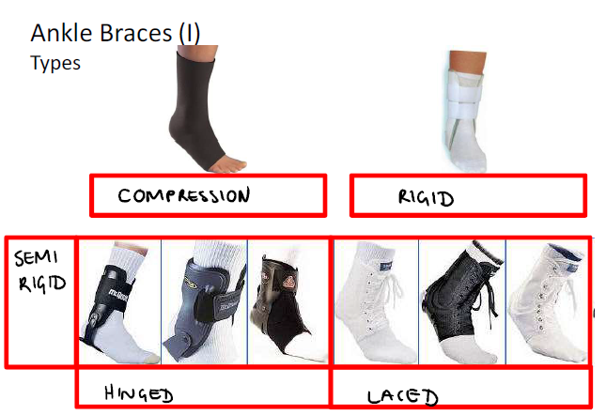Types of ankle braces
  + Compression
  + Rigid
  + Semi-rigid
    - Hinged
    - Laced
* Design requirements for ankle braces
  + Engineering
  + Functional
  + Aesthetic

Lecture 3 – Wound Healing

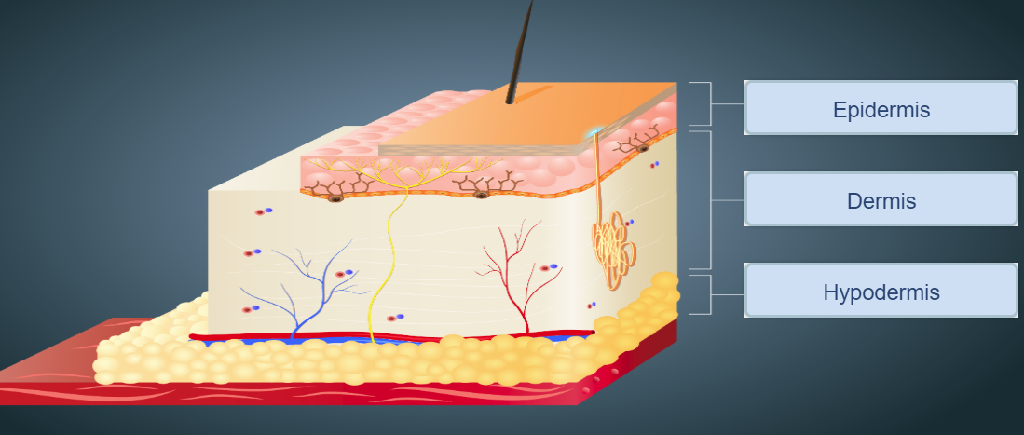SKIN ANATOMY

* Epidermis (outermost layer of skin)
  + Rich in tough protein called keratin, and containing two main types of cells:
    - Keratinocytes, barrier against environmental damage
    - Melanocytes, produces a pigment, melanin, responsible for skin color and protection of UV radiation
  + Forms waterproof barrier between body and external environment
    - Resists friction
    - Resists microbial invasion
    - Prevents water loss from body
  + Doesn’t carry blood vessels, but receives nourishment from capillaries in dermis
  + As cells of the outer surface of epidermis are shed, cells from the stratum basale (bottom layer of epidermis) divide and replenish the epidermis
* Dermis (beneath the epidermis)
  + Contains all blood vessels and most nerve tissue from skin
  + Responsible for:
    - Elasticity and strength of skin
    - supplier of nutrients for epidermis
    - Important for thermoregulation, regulate internal body temperature
  + Contains two fibres:
    - Collagen fibres, provides skin with tensile strength and resistance to stretching forces
    - Elastic fibres provide its recoil properties
  + Composed of numerous cell types:
    - Fibroblasts
    - Immune cells, eg. Macrophages
    - Adipocytes, cells that store energy as fat
  + Divide into two sub-layers:
    - Papillary region composed of areolar connective tissue
      * Formed by protrusions of dermis into epidermis
      * Interior of protrusion supply epidermis with oxygen and nutrients
      * Contains tactile receptors, known as Meissner’s Corpuscles (responsible for sensitivity to light touch)
    - Reticular region composed of dense connective tissue of thick bundles of collagen fibres
      * Contains: roots of hairs, sebaceous glands (secretes oil to lubricate skin and hair), sweat glands, receptors, nails, nerve endings and blood vessels
* Hypodermis (aka. Subcutaneous layer) lies below dermis
  + Lies below dermis
  + Connective tissue containing fat (adipose tissue: energy reserve, insulate body and cushion to protect underlying structures from trauma), blood vessels and sensory receptors
  + Functions as a protective cushion and insulator
* Muscle layer lies below hypodermis

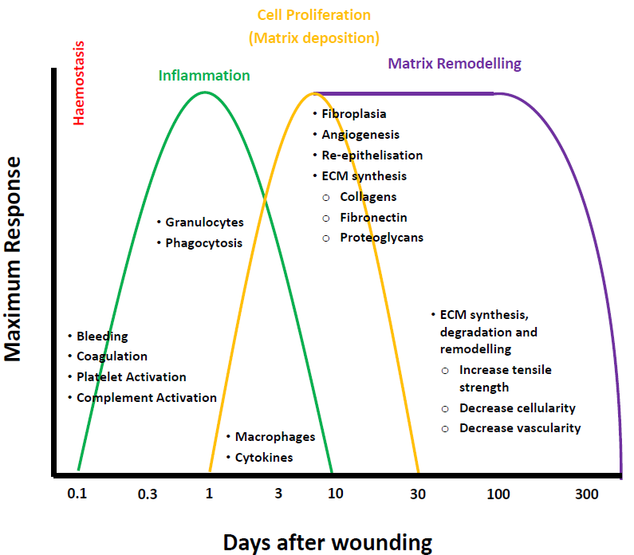SKIN ANATOMY

* Haemeostasis (causes wound to stop bleeding)
  + When cut $→$ capillaries torn $→$ bleeding
  + Injury to microvasculature (smallest systems of blood vessels in body) $→$ constriction of blood vessels
  + Coagulation cascade activated, to stop bleeding
    - Blood clotting begins to prevent blood loss and protect against viruses or bacteria
    - Platelets bind directly to collagen (protein in muscles, bones, skin, blood vessels, etc.)
    - Von Willebrand Factor (WWF) by forming additional links between platelets and collagen ( $↑$ strength)
    - Proteins formed:
      * Fibrin is an insoluble protein forms fibrous mesh and acts as a “glue” to bind platelets to each other to stop blood flow
      * Fibronectin is a glycoprotein (carbohydrate grouped protein) that anchors cells to collagen
      * Vitronectin is a glycoprotein that regulates coagulation cascade
  + Platelets release growth factors
    - Initiation of the wound healing
    - Attract and activate:
      * Fibroblasts is a biological cell combines the extracellular matrix and collagen to produce a structural framework for animal tissue to form (connective tissues)
      * Endothelial cells line inside of blood vessel to carry excess blood plasma around the body
      * Macrophages is a large white blood cell is to locate microscopic foreign bodies and eat them
* Inflammatory
  + Early Stage
    - Infiltration of inflammatory cells, due to the increased blood flow as tissue becomes reddened and swollen
      * Granulocytes is a white blood cell that has granules with enzymes to be released during infections
      * Polymorphonuclear leukocytes is a white blood cells released during infections, allergic reactions, and asthma
    - Phagocytosis is the removal of bacteria and foreign materials by phagocytes
    - Prevents infection
  + Late Stage
    - Monocytes (white blood cells) are attracted to wound area, such as macrophages
      * Growth factor and other effects on other cells release
      * Recruit fibroblasts, keratinocytes (an epidermal cell producing a fibrous protein), endothelial cells
      * Proteases, breaks down enzymes molecules as they go through tissue remodeling
* Cell Proliferation (Extra Cellular Matrix deposition)
  + Wound begins to heal
  + Migrations of fibroblasts $→$ proliferation of fibroblasts
    - Start to produce ECM proteins (mostly found in the skin) which make up the dermis
      * Fibronectin
      * Collagen (enzyme protein) gives the skin the plumpness
      * Proteoglycans
      * Elastin gives the skin elasticity (comparing between teen to old)
  + Collagen synthesis
    - Provides strength and structure to the dermis
  + Angiogenesis is the formation of blood vessels from pre-existing ones
    - Big wound $→$ blood vessels need to be replaced (within 200 microns) $→$ Angiogenesis causes the blood to be replaced for nutrients to be applied, so wound can heal
    - Macrophages release angiogenic factors to switch on and produce new blood vessels
  + Granulation tissue formation
    - Capillaries
    - Proliferating fibroblasts
    - Macrophages
    - Collagen
    - Glycoproteins
  + Epithelisation
    - Reformation of the epidermis
      * Migration of keratinocytes across the top of the dermis (wound)
* Matrix Remodeling (Regeneration)
  + Cells deposit matrix while remodeling the tissue, simultaneously
  + Occurs over prolonged time periods depending on the size of the injury
  + Breakdown and remodeling of ECM proteins, including collagen
  + As time passes, process slows down as wound is fully healed

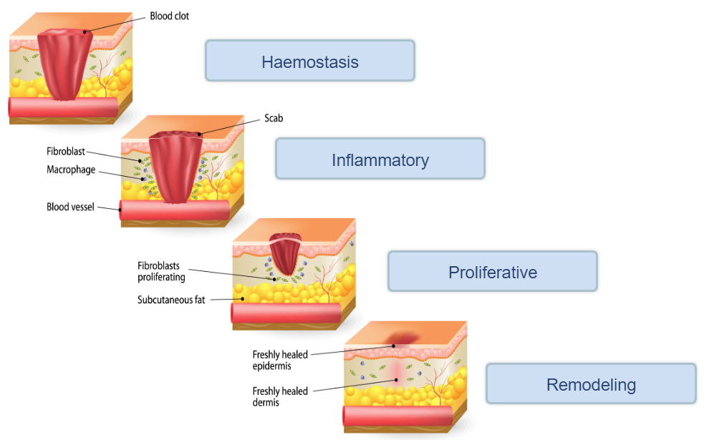

ABNORMAL WOUND HEALING

* Hypertrophic scar (Hyper $→$ increasing)
  + Confined to the border of original wound
  + Reduce in size over time
  + Use of collagen (from fibroblasts)
* Keloid scar
  + 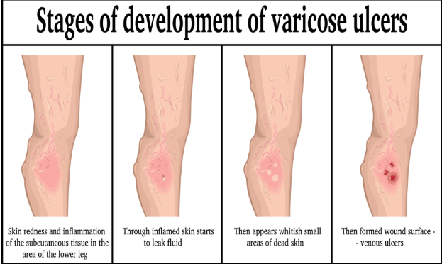Genetic issue, so when removed, it can come back
  + Extend beyond the border of the wound (overgrowth of scar tissue)
  + Will not reduce over time
  + Thick collagen (excess collagen provided)

CHRONIC WOUND

* Venous Ulcer
  + Non-functioning of venous valves, usually of the legs
    - insufficient blood flow
    - 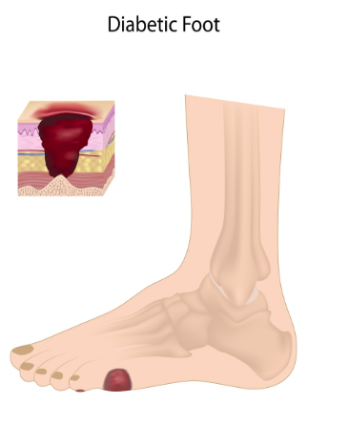build-up of inflammatory cells
    - insufficient removal of waste produced by inflammatory cells
* Diabetic Ulcer
  + Normally diabetes type 2 and seen on foot
  + Pathologies that are associated with diabetic patients
    - Peripheral neuropathy – form of nerve damage, causing patient not to realize wound $→$ delayed wound care
    - Peripheral arterial disease – similar to venous ulcer $→$ limited blood flow causing build-up of inflammatory cells and waste
    - Infection – puts diabetic patients at a greater risk of wounds $→$ worsen wounds and may require amputation
* 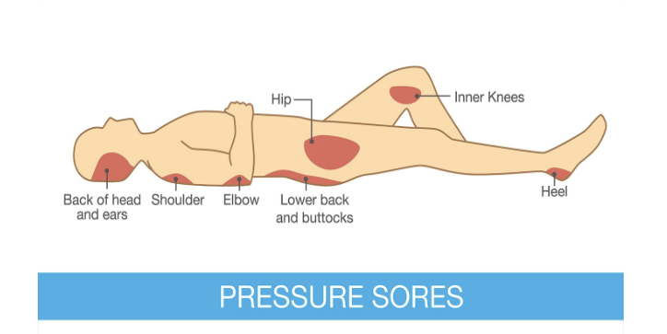Pressure Ulcer
  + Commonly caused by restricted blood flow or absence of blood flow to region
    - Found in limited mobile patients and patients being in same position with increased pressure for a long period of time

TREATMENT OF CHRONIC WOUNDS

* Problems
  + Heterogeneous – all cases are different $→$ different measures to be accounted for
  + Underlying conditions – genetic symptoms/problems pre-existing before the problem
  + Age – elderly
* Common courses of treatment
  + Debridement is removing damaged tissues or foreign objects from wound
  + Dressing
    - Sterile pad or compression
    - Promote healing and protection from further harm
  + Compression/pressure bandages, negative pressure therapy
    - Compression bandages used to control fluids exerted from wound and reduce swelling in region
    - Pressure bandages compresses dead space and prevents blood clotting and blood plasma formation
    - Negative pressure therapy uses a vacuum dressing to promote and enhance healing in acute or chronic wounds, and 2nd or 3rd degree burns
  + Skin grafts
    - Taking healthy skin to be transplanted to a new site on patient’s body
    - 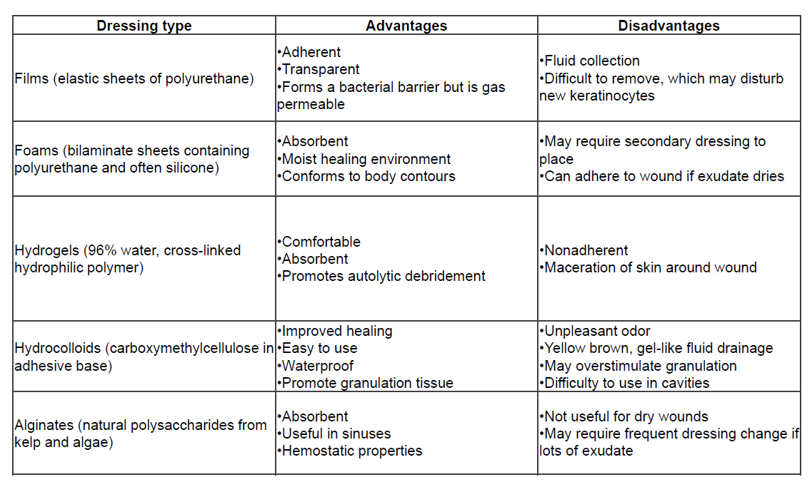Fixes original wound, while making another wound

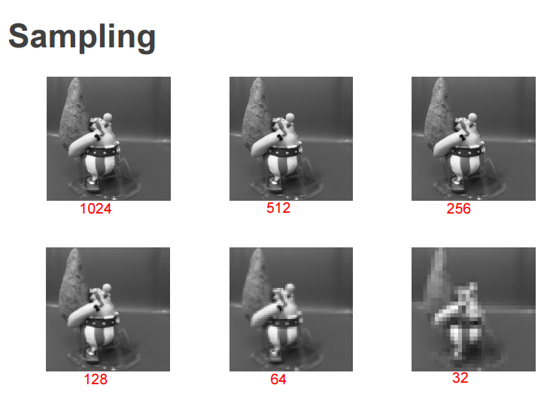Lecture 4 – Image Processing for Physiological Measurement

IMAGE PROCESSING

* Human vision $→$ easily biased, different perceptions
* Automated image analysis $→$ unbiased, extract info from image data and tests hypothesis

IMAGE VS DIGITAL

* Image: 2D with x and y coordinates plane
  + Amplitude (f) is intensity at coordinate
  + Values varied over infinite space
* Digital: Same as image
  + Except values are finite $→$ pixels, have particular position and f value
  + Restrictive space
  + Pixel location of 2D function: f(x,y,) = z $→$ f(row, column) = pixel intensity value

COLOUR VS GRAYSCALE

* Comes from pixels in digital image
* Colour
  + 3 channels $→$ RGB (Red, Green, Blue) colour intensities
* Greyscale
  + 1 channel $→$ range from black to white
  + Intensity stored as 8-bit binary no. (0-255)
    - Eg. 0 $→$ X $→$ 255 , black $→$ grey $→$ white
    - Saturation of grey depends on which side it leans towards
    - Intensity of colour = avg. of values in selected space

SAMPLING

* Changing the picture resolution
  + Lowering resolution $→$ increases blur between pixels $→$ unclear image

MATLAB coding

* imresize(variable given to image, [Original pixel size]/sampling factor)
  + Eg. imC = imread(‘pepper.png’)             [loading picture]
  + imG = rgb2gray(imC)                        [convert RGB $→$ grey-scale]
  + im1 = imreszie(imG,[1024 1024])     [initial pixel size of image]
  + 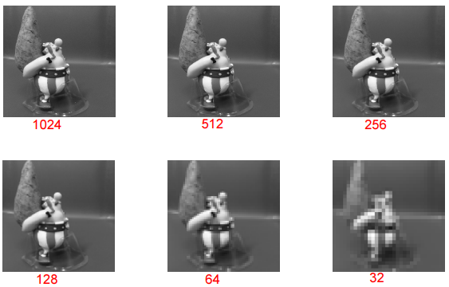Im2 = imresize(im1,[1024 1024]/2)   [sampling to sampling factor]

QUANTISATION

* Convert light intensity and frequency into digital color values
  + Smudges light colours into shades of black
* MATLAB coding
  + [new image name,map# quantising factor] = gray2ind(converted image, quantising factor)
  + imC = imread(‘pepper.png’)
  + imG = rgb2gray(imC)
  + [im2,map2] = gray2ind(imG,2^7)

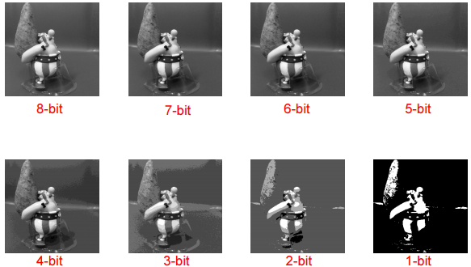

RESIZING IMAGE

* Zoom-in $→$ poor resolution $→$ blurred image
* Assign value to pixel in output image $→$ value = location $→$ resized image

2D INTERPOLATION METHODS

* Using known values/points, to estimate values of unknown points $→$ alter picture format
* Nearest neighbor interpolation
  + Nearby values in space around given point are similar to the given point
  + Squares reduce down, to determine, square location
  + f(x,y) = f(floor(x),floor(y))
  + In pic, space close around black dot $→$ coloured same
  + 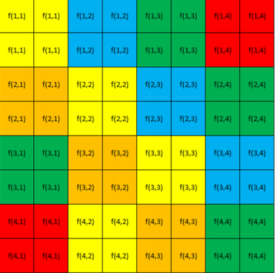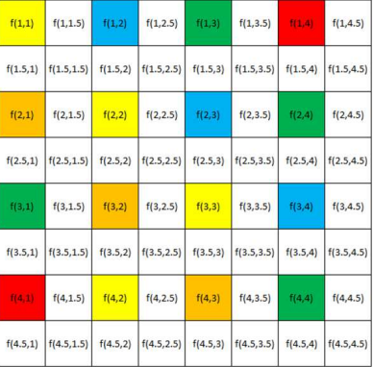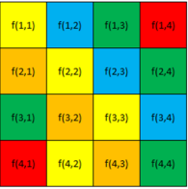Final picture blurred $→$ when zoomed $→$ squares are formed $→$ proof of method
* Bilinear interpolation
  + Averages values around initial value $→$ converts to new colours
    - Average out between two fixed distinct points $→$ mixture of the two colours $→$ causes blur between the two points of contact

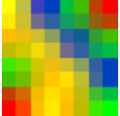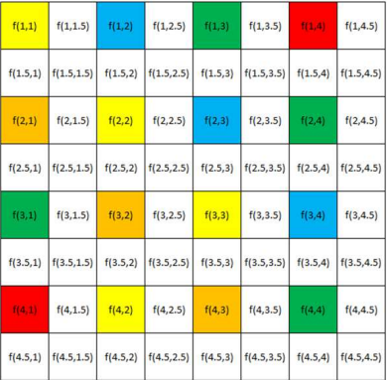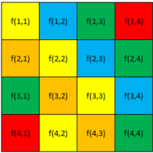

* Bicubic interpolation
  + Average out between 16 nearest pixel values $→$ mixture of all 16 pixel values $→$ causes blue between points of contact
  + Clearer than bilinear interpolation $→$ Average more pixel values = clear image

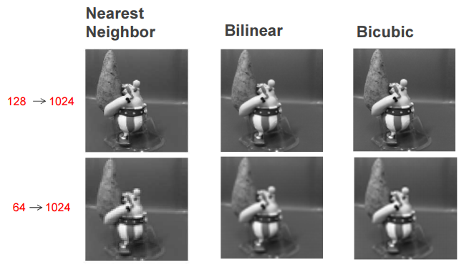

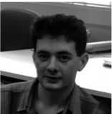LOGARITHMIC TRANSFORMATION

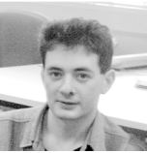

* Q(i,j) = c*log(1 + |*P(i,j)*| )
  + 1 + $→$ log(0) is undefined
  + c is constant scaling factor for, Q(i,j) = 255  if |*P(i,j)*| = max input value
  + log has any base $→$ can be defined by question
* Enhance low-intensity pixel values $→$ BUT lose information on high pixel values eg. pictures with a lot of detail
* Eg. Spreads dark face pixels over wider range, while higher values are compressed $→$ greater detail in unclear spots of original, but blurs detail in clear spots of original

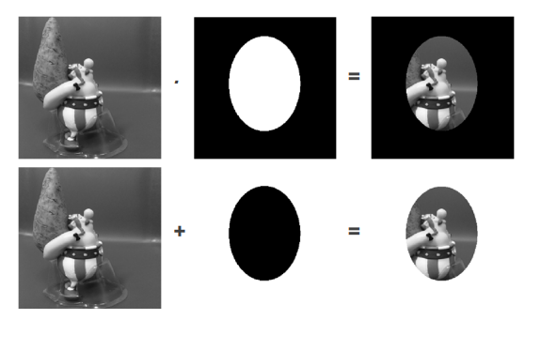LOGIC OPERATIONS

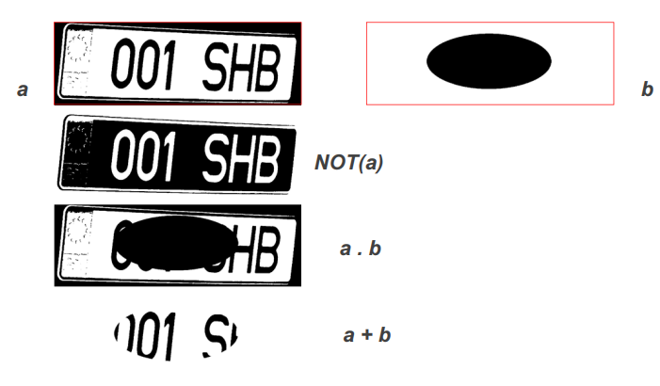

FILTERING

* Remove noise (dots, speckles, stains) $→$ clearer photo
* Uses
  + Noise removal: remove speckles/dots in image
    - Either mean or median values of neighboring pixels
    - = low-pass filtering
      * But may have blur edges $→$ more advanced techniques needed (eg. adaptive or edge preserving)
* Mean/Average filter
  + Replace pixel by average of pixels surrounding specific pixel
  + Average out sharp transitions $→$ smooth image
    - More pixels taken for average $→$ remove more noise $→$ BUT blur detail
  + Most have data as fractions
  + Filter kernel: the degree of filter used
  + MATLAB coding
    - I = imread (‘coin.png’) [read grayscale image]
    - H = fspecial(‘average’, [3,3]) [create pre-defined 2-D filter]
    - J = imfilter(I,H) [apply filter]
    - OR I = imread(‘coin.png’) [read grayscale image]
    - K = ones(3,3) / 9 [define filter kernel]
    - J = conv2(I,K,’same’) [perform convolution, but keep sizing of I)

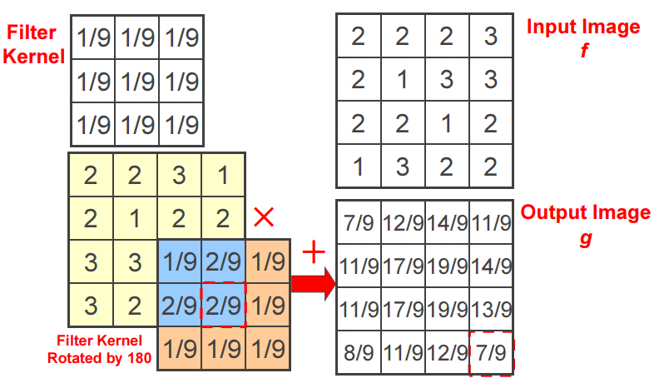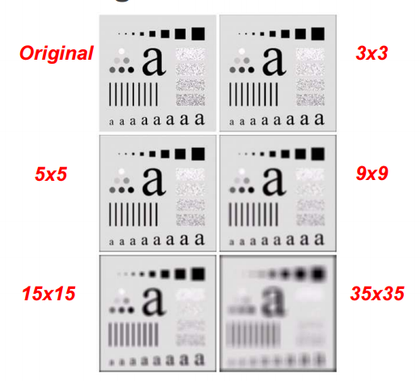

* Weighted Average filter
  + Closer-by pixels have higher weighting $→$ far-away pixels have lower weighting
  + All data values are positive
  + Keeps low-frequency, BUT suppresses high frequency = low-pass filter
  + Problems
    - Blur edges/details $→$ unclear image
    - Not effective against impulse noise (random high intensity pixel) $→$ salt and pepper
  + MATLAB coding
    - I = imread(‘coins.png’) [read grayscale image]
    - Figure; imshow(I) [display image]
    - K = [1,2,1;2,4,2;,1,2,1] / 16 [define filter kernel]
    - J = conv2(I,k,’same’) [perform convolution, keeping size of I]
    - Figure; imshow(uint8(j)) [display image]

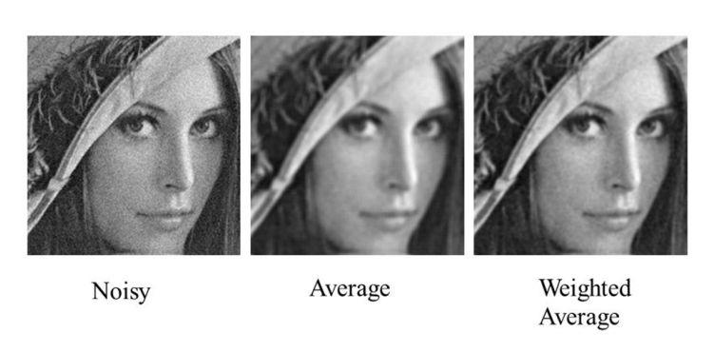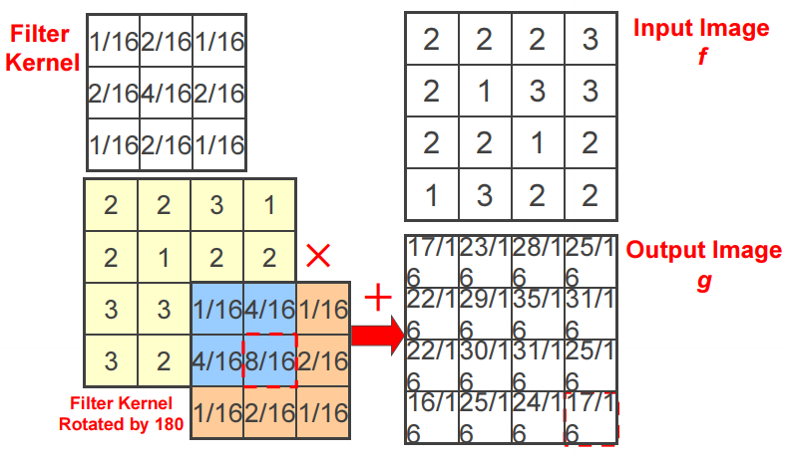

* Median filter
  + Takes median value of surrounding pixels around specific pixel
    - Sort pixels in increasing order $→$ take middle one
  + Improves image severely corrupted by defective pixels
  + MATLAB coding
    - I = imread(‘coins.png’) [read grayscale image]
    - I = imnoise(I,’salt & pepper’,0.02) [add salt and pepper noise to image]
    - Figure; imshow (I) [display image]
    - J = medfilt2(1,[3,3]) [perform convolution, while keeping size of I]
    - 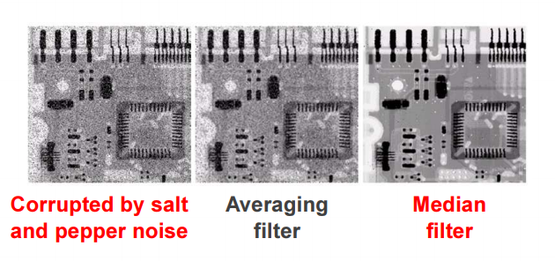Figure; imshow(J) [display image]

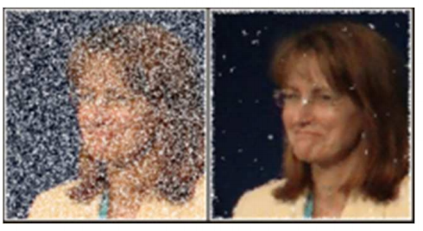

IMAGE SHARPENING

* Enhanced image = original image + scaled version of line structures and edges in image $→$ greater detail on image
  + Line structures and edges obtained = high pass filter
  + 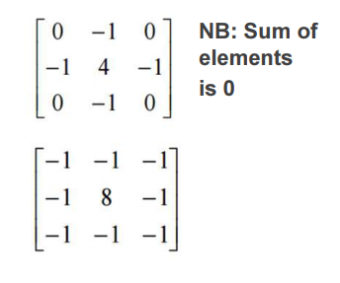Data values: weighted average operation, but some are negative and ∑= 1
  + High-pass filter
    - Difference of current and average of nearby pixels (weighted averaging)
    - Used for edge detection
    - Example on right $→$
  + MATLAB coding
    - I = imread(‘coins.png’) [read grayscale image]
    - Figure; imshow(I) [display image]
    - K = [0 -1 0; -1 -4 -1; 0 -1 0] [define filter kernel]
    - J = conv2 (I,K,’same’) [perform convolution, keeping size of I]
    - 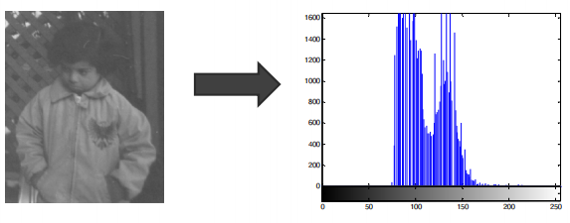Figure; imshow(unit8(J)); [display image]

IMAGE HISTOGRAM

* Graphical representation of pixel intensity distribution $→$ plot number of pixels for each pixel intensity
  + Scanned $→$ running count of no. of pixels at each intensity value

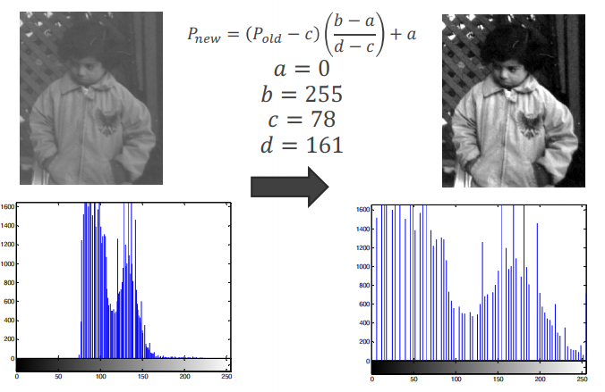CONTRAST STRETCHING

* Improve contrast in image by expanding range of intensity values
  + Important to specific upper and lower pixel value limit
* MATLAB coding
  + I = imread(‘pout.tif’) [read image]
  + Figure; imshow (I) [display image]
  + Figure; imhist(I) [display histogram]
  + [minI,maxI] = stretchlim(I) [find max. & min. intensity value]
  + J = imadjust(I,[minI,maxI],[]) [perform contrast stretching]
  + Figure; imshow(J) [display image]
  + 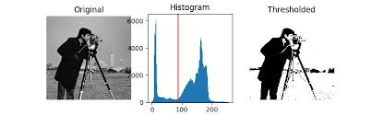Figure;imhist(J) [display histogram]

HISTOGRAM EQUALISATION

* Pixel distributed evenly over whole intensity range $→$ flat histogram

THRESHOLDING

* Bi-modal: pixel intensities are clustered around two well-separated values
* Threshold between two peaks $→$ no peaks = threshold not determined by uneven distribution
* 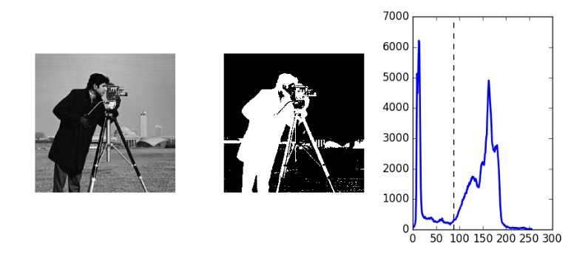Histogram of image $→$ determine two max peaks $→$ determine threshold level via average peak

OTSU THRESHOLDING

* Chooses threshold with minimum different between white and black pixels
* MATLAB CODING
  + Read grayscale image $→$ level = graythresh(I) [determine otsu threshold] $→$ convert grayscale image to binary image $→$ display image

MORPHOLOGICAL OPERATIONS

* Binary regions by thresholding $→$ distorted by noise and texture $→$ morphological operations remove imperfections
* Non-linear operations $→$ creates a new binary image $→$ pixels have non-zero values only if test is successful
* Probe image with a template called structuring element
  + Structuring element = small matrix of pixels
  + Dimensions depend on whatever is chosen
  + Pattern of ones and zeros to specific shape
  + Marked with 0 $→$ intersects of hits structuring element, marked with 1 $→$ structuring element fits
* Each structuring element placed on each value of the original image, to produce output image

MORPHOLOGICAL EROSION

* Tests whether structuring element fits
* 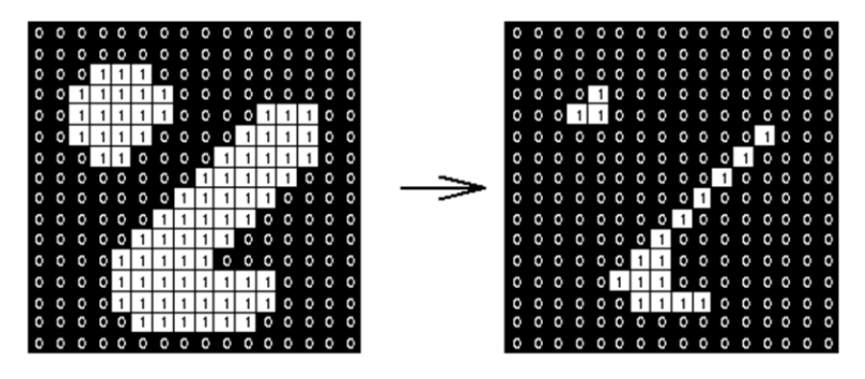Eg. Used to separate touching objects to count them all up

MORPHOLOGICAL DILATION

* 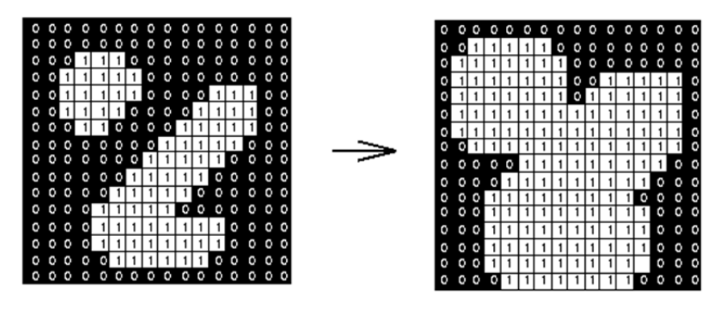Tests whether structuring element ‘hits’ $→$ filled space with zero

MORPHOLOGICAL OPENING

* 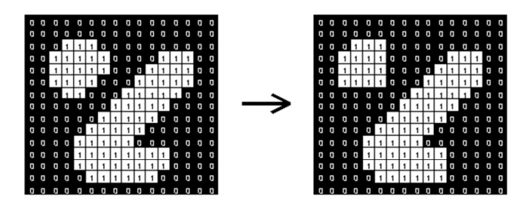Morphological erosion followed by dilation with same structuring element
* Can separate out circle from lines, or, horizontal with vertical lines

MORPHOLOGICAL CLOSING

* 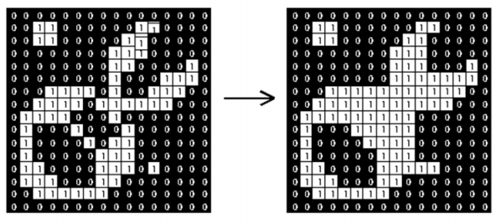Morphological dilation followed by erosion with the same structuring element

MATLAB FUNCTIONS

* Imread (): reads image $→$ ensure to have file type at end, eg. ‘office_2.jpg’
* Figure; : open into new window
* imshow(): displays image
* imcomplement(): invert colour $→$ white turns black, while black turns white
* imsubtract(): difference of intensity of two images $→$ new output photo
* imhist(): display a histogram
* histeq(); peform histogram equalization
* im2bw(image variable, threshold value (between 0-1)): convert grayscale image to binary image
* regionprops(image variable, ‘properties’): returns set of properties from components of binary image

Lecture 5 – Ethics in Engineering

MEANING

* + Set of standards of human behavior
  + Code of professional conduct
  + Values of right and wrong, or set of moral principles

TYPE OF ETHICS

* + Professional Ethics
    - Honest and impartial
    - Not publishing false reports
  + Patient Ethics
    - Confidentiality
    - Full disclosure of patient details
  + Natural & Human Ethics
    - Not interfering with nature and life
    - Not pulling the “playing God” act

CODES OF BIOMEDICAL ENGINEEERING ETHICS

* + Hippocratic oath – medical ethics
  + ABET & IEEE codes – engineering ethics
  + Biomedical engineers – indirect practitioners (works closely with clinical practitioners)
  + Associations with these codes ^:
    - Accreditation Board of Engineering Technology (ABET – USA)
    - Engineers Australia
    - IEEE (Institute of Electrical and Electronics Engineers)
    - Biomedical Engineering Society (BMES)
    - American Society of Mechanical Engineers (ASME)

CONSEQUENCE OF BREAKING CODE OF ETHICS

* + Despite not being the law; legal prosecution focused on the outcomes of such behavior can happen

Eg. Personal injury or class action lawsuits

* + Lose reputation, credibility, employment and research funding (such as; peers, elite organizations, government and funding agencies)

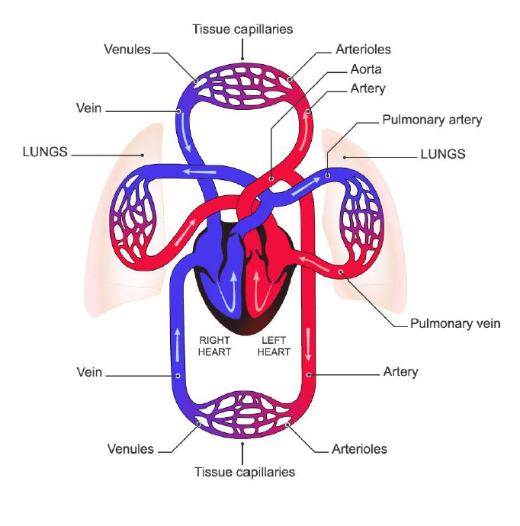Lecture 6 – Bionic Hearts

PART 1 – CARDIOVASCULAR PHYSIOLOGY (NOT EXAMINABLE)

PURPOSE

* Transports oxygen to body cells and takes away carbon dioxide (mainly)
* Regulates body temperature and water content of cells
* Carries white blood cells and antibodies to protect against disease

CIRCULATION

* + Left Heart has oxygen-rich blood
    - Pumps blood into aorta (largest vessel) out of left ventricle
    - Blood $→$ Collarbones $→$ limbs + legs
    - Blood $→$ aortic arch $→$ brain and body (eg. Kidney and guts)
  + When blood moves, blood vessels get smaller
    - Largest = aorta
    - Smallest = tissue capillaries
    - Oxygen leaves blood for tissues, while CO2 leaves cells into blood
  + Blood in vena cava $→$ Right heart
    - No oxygen in right heart, since all gone to cells
    - REPEAT: Pumps deoxygenated blood to lungs to pick up oxygen and drop CO2, and returns to left heart
  + 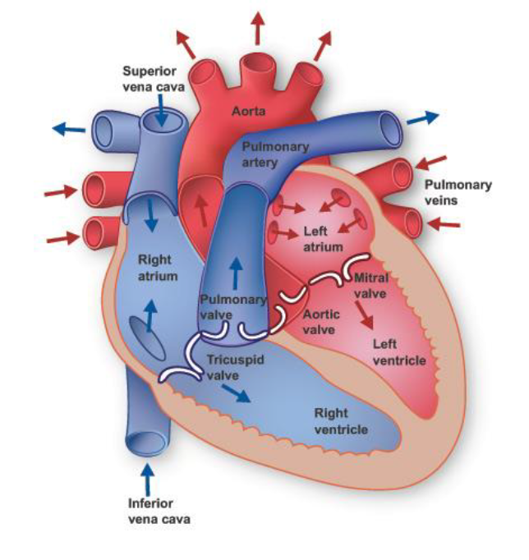Ventricles = main driving force
    - Left Ventricle bigger than right ventricle
      * 5-10x more energy, $∴$ more pressure
      * More skin on outside, so muscles squish more blood out
  + Atria/atrium
    - Collects blood before it goes into ventricles
    - Right atrium receives deoxygenated blood from veins
    - Left atrium oxygenates blood from pulmonary veins
  + Heart has 4 valves
    - Blood is one-directional
    - Heart is pulsatile (relaxes and contracts), to continue flowing blood
  + Question: What happens to pressure and flow in systemic circulation when the left ventricle fails? (see pic)
    - Flow and pressure goes down
    - Less force, less energy
    - Min flow rate/pressure to allow blood to into tissue
  + Question: What happens to pressure and flow in pulmonary circulation when the left ventricle fails? (see pic)
    - Pressure rises as right heart pumps strongly
    - Accumulation of blood, since left heart does not function
  + Question: Do you think that the body compensates for LV heart failure? Yes/No?
    - Yes
    - Needs to maintain cardiac output (amount of blood pumped/min) and RAP (blood pressure of right atrium)
    - Heart beats faster to maintain $→$ attempts to gain oxygen in heart $→$ increase muscle mass (due to overwork) $→$ heart enlargement

HEART DISEASE

* + Causes: dysfunctional heart valves, virus, birth defects or coronary artery disease (damage in heart’s blood vessel)
  + Heart has to be alive when taken out (eg. On life-support) $∴$ Not-enough donors

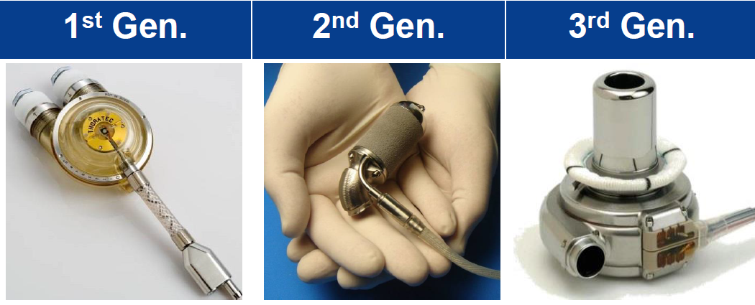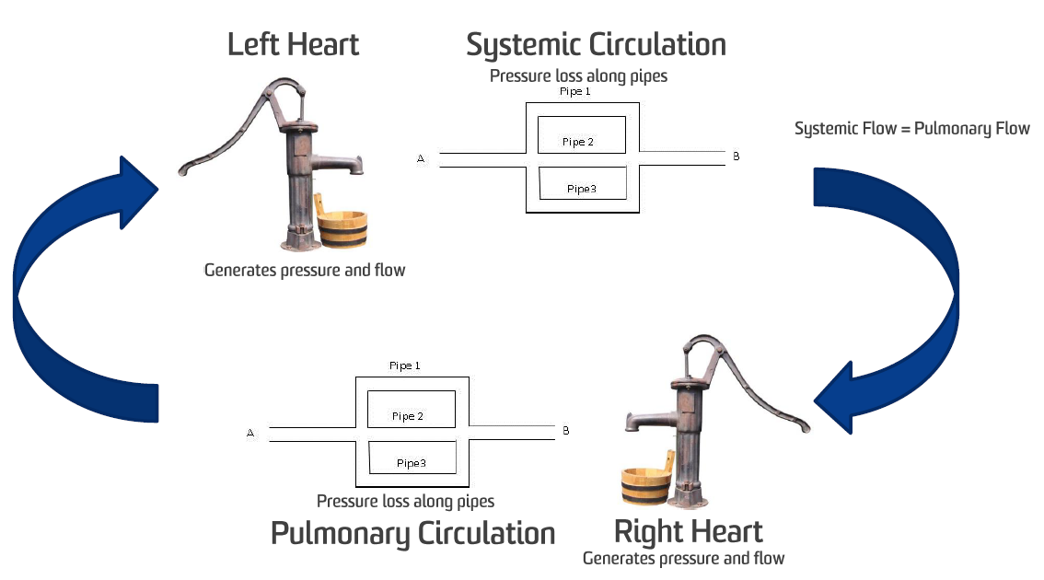PART 2 – MECHANICAL THERAPY (EXAMINABLE)

VENTRICULAR ASSIST DEVICES (VADs) supports failing ventricles

* + 1st Gen
    - Tried to mimic heart
    - Pneumatic (air or pressurized gas)/electric
    - Sits outside of body (usually)
      * Can see blood going in and out
      * Connected to large air compressor $∴$ lack mobility $→$ poor quality of life
      * Very uncomfortable
    - Prone to infection, especially around tube gap into body
    - Potential to create blood clots in valves
    - Provide short term support
    - Aged out in developed countries because of poor functionality
  + 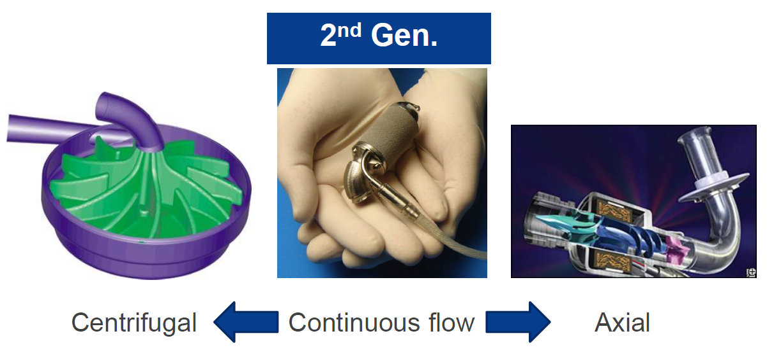2nd Gen
    - Adapted a more continuous air flow; centrifugal or axial
    - Longer support (approx. 8 years) compared to 12-24 months
    - Steady decrease of survival over prolonged time
    - Small – sized $→$ more mobility
    - Electronically driven
      * No pump = no air compressors
      * Less power requirements
    - Disadvantages:
      * Mechanical contact $→$ formation of blood clots
        + Goes through impeller $→$ breaks it $→$ loses functionality
        + Size Growth $→$ jams impeller $→$ VAD breaks down
        + Goes through untouched $→$ travels to patient’s brain $→$ death
      * 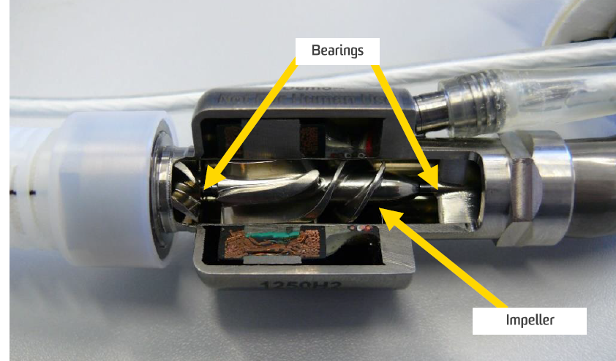Blood Damage
      * Infection
    - DESIGN:
      * Impeller = spiral disk
        + sucks blood and pushes it back out with higher flow rate
        + Needs bearing to spin
      * Thrust Bearing
        + Stop impeller from moving
      * Point of contact with bearings
        + Very high shear stress
        + Blood cells caught and torn to shreds
  + 3rd Gen
    - Continuous flow: axial + centrifugal
    - Completely implantable, with small cable exiting body
    - No mechanical wear $→$ impeller has no contact with any parts
    - DESIGN:
      * **Hydrodynamic** Bearings
        + Disk spins fast $→$ little slope on bottom generates lift force $→$ allows impeller disk to float above
        + High-pressure fluid (blood) underneath rotor
        + Rotor surfs on top of blood
        + 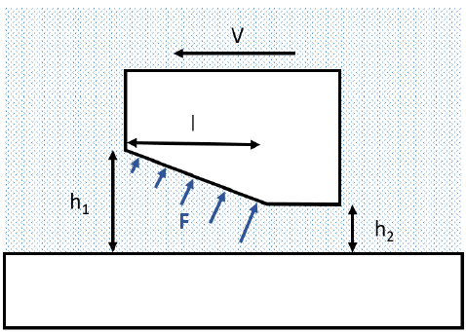Clearance (h = height between rotor/impeller and housing) needs to be large enough to prevent blood trauma
        + Small Clearance (h) required to generate pressure

Too big, won’t generate lift force

Blood is thick, so high shear rates can damage it

$∴$ Clearance needs to be big enough to allow blood undamaged, but small enough to generate enough lift force to lift impeller off housing

* + - * + Changes in clearance requires change in speed or surface area
        + Min start-up speed required to maintain lift force

Not fast enough = drags impeller along casing $→$ damage blood cells

* + - * **Electromagnetic** bearings
        + Magnets on either side of the impeller suspends the impeller between them
        + Can do large gaps $→$ prevents blood cell damage
        + Magnets are large and bulky
        + More power than hydrodynamic
        + Requires additional sensors for control over rotor position

VADs GENERAL COMPLICATIONS

* Bleeding is biggest
  + Patients often take anti-clotting meds
  + Greater risk of death if they get a cut/graze
* Infection
* Potentially due to trauma at exit site
  + Patient’s movement causes driveline (cable) to wiggle $→$ damage suture, etc.
  + Easier for bacteria to enter
* 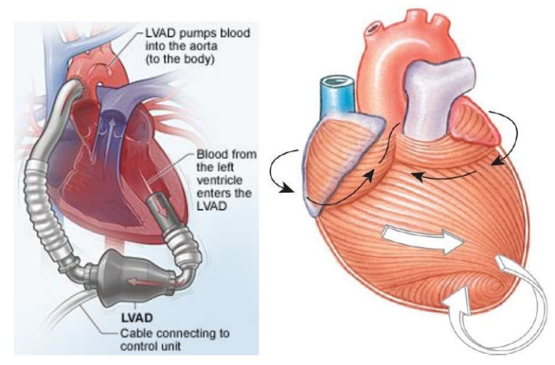Require daily monitoring and dressing changes
* Very difficult to treat
* Driveline design and coating can cause VAD infection
* Have tried transcutaneous energy transfer (wireless)
* Right Heart failure (see right)
  + Right ventricle needs to keep up with left side
  + LVAD support, more common
  + Can use two 3rd gen LVAD’s, since Bivads have poorer survival rates
  + Cause respiratory failure
* Neurological dysfunction
  + Due to thrombus (clots) forming in ventricle or LVAD
  + Important to optimize LVAD and ventricular flow dynamics
  + Cannula design reduces neurologic complications from ~23% $→$ ~4%
* Cardiac Arrhythmia
  + Irregular heartbeat
  + Cause reduced blood flow, right heart failure, thrombus
  + Caused by cannula-heart interference
  + Heart can be sucked onto cannula by negative pressure created by LVAD

TOTAL ARTIFICAL HEARTS (TAH)

* + Completely replaces the heart, ie. takes out heart and replaces completely
  + Used if:
    - Native heart cannot support life
    - Ineligible for transplant (ie. Not enough heart donors)
  + Large-sized; needs large patient
    - Some women and children ineligible
  + Similar principle to 1st Gen VADs
    - Pulsatile pump (with valves) connected to huge air compressor
    - Same disadvantages as 1st Gen VADS, ie. size or lack mobility
  + 2nd and 3rd Gen VADs
    - Whole heart taken out and replaced with turbines
    - No heartbeat $→$ continue flow
    - Worked on animals
    - 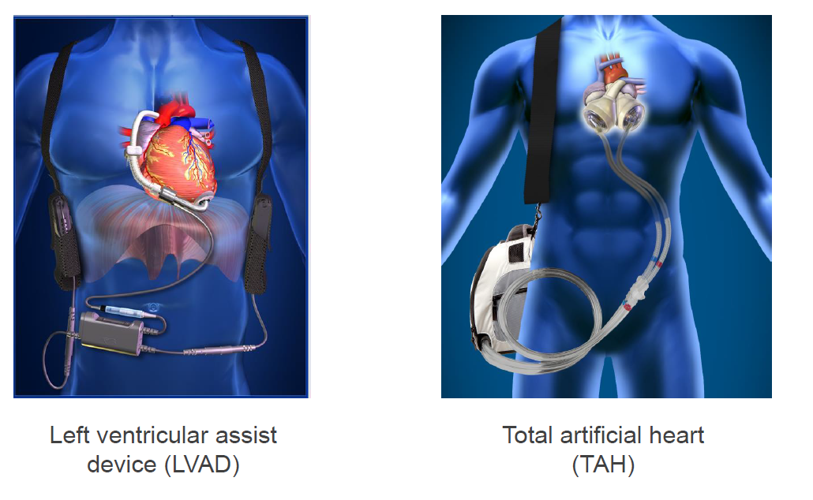Worked on first impromptu patient $→$ died soon after

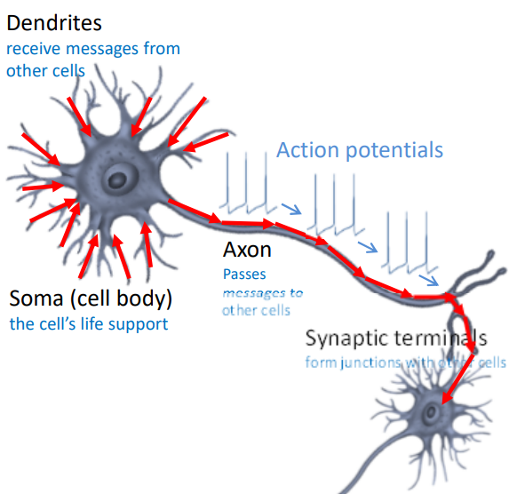Lecture 7 – Excitable tissue, neural interfaces and bionic eyes

PART 1: BIONIC NEUROPHYSIOLOGY

STRUCTURE OF A NEURON

* + Dendrites
    - Reach out/add and summarize messages and signals from other cells
    - Dendritic arbor: used to collect/sense environment
  + Messages from here are communicated to the SOMA
    - * SOMA = cell body/machinery
  + Travels to the formation of AXON
    - If there is enough activity, it creates an action potential
      * Action potential can propagate down axon to synapses where it communicates with other dendrites
    - The wrapping about the axon = myelin
      * Myelin sheath = fatty layer on cell exterior (ie. like wire insulation)
      * Allows AP to propagate faster with less energy
      * Some diseases can cause loss of myelin sheath, causing slow propagation of AP
    - Axon not fully insulated, or else AP won’t propagate
      * Myelin sheath has gaps
      * Gaps = node of Ranvier
      * AP form and propagate between gaps

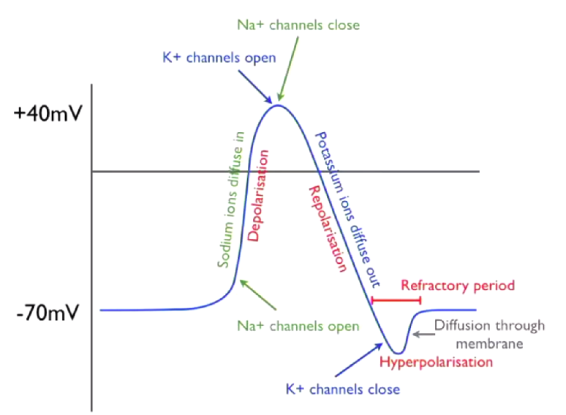ACTION POTENTIAL (AP)

* + Pulse-like wave that travels long excitable cell membranes
  + Travels via axon
  + All or none process (either: nothing happens, or all steps below occur, at about same mV values)
  + Repetitive process, travelling along length of axon in node of Ranvier
  + At rest, voltage in cell = -70V (resting potential)
    - Maintains this by pumping Na and K
  + If chemical signals received by dendrites are sufficient to cause voltage to get to threshold point (ie. -55mv)
    - Sodium channel opens = depolarization
    - Voltage increases to max point (40V)
    - After this point, sodium channel deactivates and K+ channel opens
    - Cells polarize to negative membrane
      * 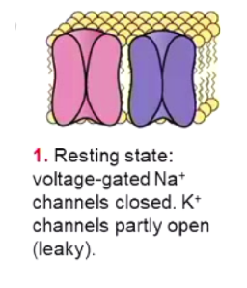Tends to overshoot $→$ K channels remain open (while Na is inactive) $→$ membrane potential becomes more negative $→$ but overshoot will come back to resting potential = hyperpolarization

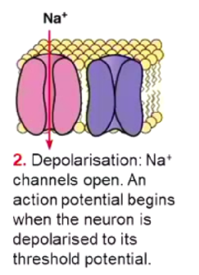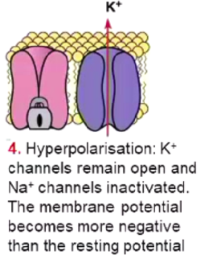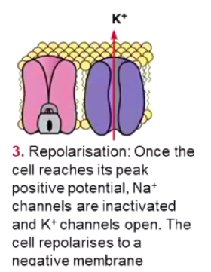

MEMBRANE AND ION CHANNELS

* + All signals caused by chemical gradients and diffusion of cells among cell membranes
  + Inside cell = high levels of K+ ions and low levels of Na+ ions
    - Opposite on the outside
  + Membrane has separate ion channels for different ions
    - Ion channels differentiates between excitable tissue and normal tissue
    - Channels are picky and selective for specific ion species
    - Na channel only lets sodium ions go from outside to inside of cell
      * Effectively has three gates
        + One is voltage sensitive
        + Other is time sensitive

It will shut down after a certain period, independent of what voltage is across the membrane

* + - * + 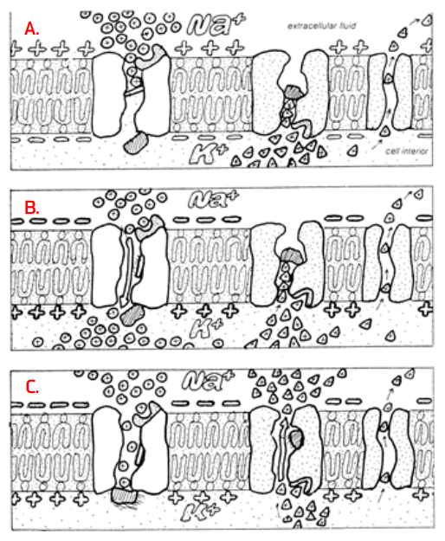Has an activation and deactivation gating variable
    - K channel only lets potassium ions go from inside to outside of cell
      * Single gate that opens depending on voltage across cell membrane
  + A,B, C are processes that occur when cell reaches ‘threshold’ (when a few sodium channels start to open)
    - (A) Na and K leak through membrane, bringing membrane back to resting potential
    - Na Opening $→$ inside of neuron more positive (as voltage increase, all sodium channels open) $→$ rush of Na into cell (B) $→$ after a period, Na channels deactivate/close
    - More Na+ increases positivity of channels $→$ enough for K channels to open $→$ repolarization (C): potassium ions diffuse into membrane $→$ increasing negativity of channel interior
    - When potassium channels open and close slowly $→$ Too much potassium goes inside = overshoot/hyperpolarisation
    - Refractory period = between time of hyperpolarisation to when membrane returns to resting potential

CARDIAC MUSCLE

* + Duration of cardiac action potential is 100x more prolonged than in skeletal muscle/nerve impulse
  + 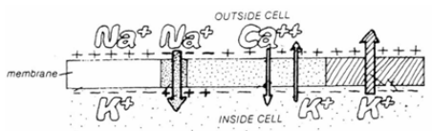Long refractory period $→$ Allows sustained contraction of cardiac muscle
  + Plateau sustained by slow Ca2+ entry and slow K+ flow out
    - When AP initiates, calcium ions flow as well
    - Ca ions maintain plateau $∴$ elongated refractory period

ELECTROCARDIOGRAMS

* + 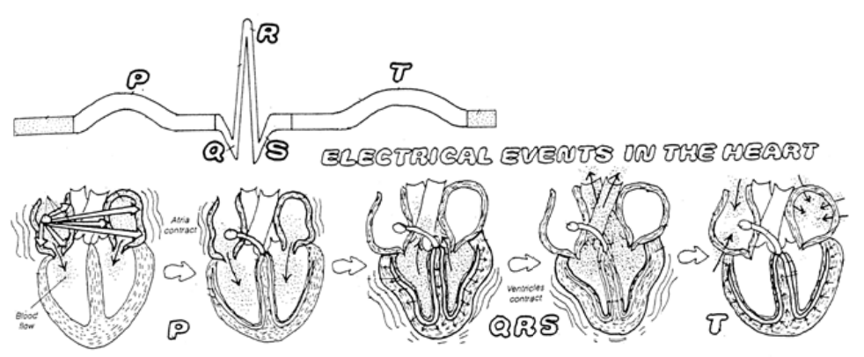Pacemaker in right atrium $→$ regularly create AP $→$ AP propagates from top to bottom of heart in controlled manner
  + Controlled electrical activity allows ECG to form and be detected at body surface
  + P – wave occurs when top of heart/atria contracts
  + QRS complex
    - Ventricles contact
    - Repolarization of atria is hidden under QRS wave (due to relatively smaller size)
  + T-wave occurs when ventricles repolarize/relax
  + ECG records cell potential of all cells during heart beating at certain timings (mV)
    - Signals can be disrupted by noise (eg. Squeezing body parts or breathing)
  + Interface is critical!!!
    - Shoving electrode nails in ourselves = v crude
    - # of functional channels increase = Better patient quality of life
    - 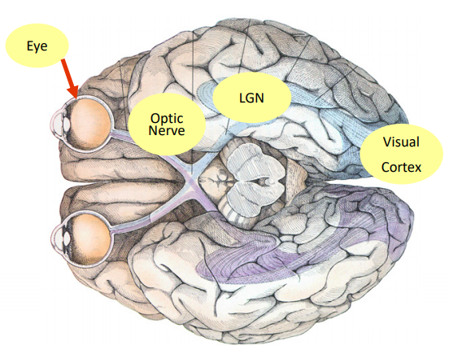Eg. Cochlear implants aren’t perfect substitutes, as they can’t distinguish between different pitches

PART 2: NEURAL INTERFACING AND NEUROPROSTHESIS

THE HUMAN VISUAL PATHWAY

* + Light signals $→$ passes through cornea $→$ lens $→$ retina (back wall of the eye) $→$ optic disk $→$ lateral geniculate nucleus $→$ visual
  + Visual Cortex occupies a huge section of the brain because of the complexity of processing images
  + Left side brain = process images from RIGHT EYE, and vice versa
  + The function of non-retinal components of ocular anatomy is to maintain a focused and clear image of visual stimuli fixed on the surface of the retina
  + Lens + eyes + muscles = maintain stable image when head shaking
    - Vestibulo-ocular reflex causes eye movement
  + Three layers/tunics in eye structure
* TUNIC 1 = outside tunic = sclera and cornea
  + Sclera (white bit) maintains the eye globe
  + Anterior surface covered by conjunctiva (under eyelid; pink scaly thing)
  + Cornea (clear bit in front of eye) is non-vascular (no blood vessels) and continuous with sclera
    - Forms 15% of globe anterior
* TUNIC 2 = choroid, ciliary body and iris
  + Choroid = 85% of globe anterior
    - Provides blood/nutrients to the retina; connects to ciliary body and iris
    - Loosely externally connected to sclera and internally connected to retina
    - Most vascular part of the body (greedy of energy)
  + Ciliary body produces gel/aqueous humor and adjusts eye curvature to focus on nearby objects
    - Ciliary muscles help focus image on retina by changing its shape/curvature, but DOES NOT move lens back and forth
* 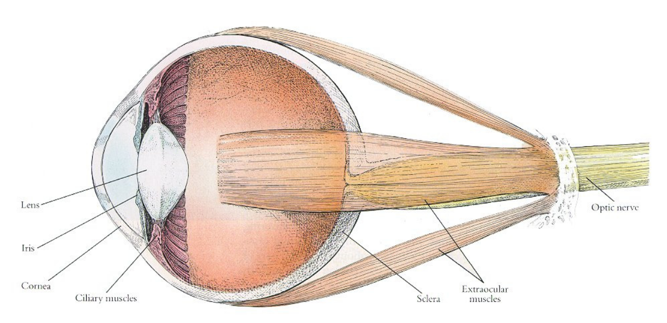TUNIC 3 = inner tunic = retina
  + Forms interior surface of eye form fovea centralis to ora serrate near ciliary body
  + Consists of 10 layers between choroid (outer surface) and vitreous humour (inner surface)
* CORNEA
  + Light enters at anterior surface of cornea
  + Approx. 2/3 of refraction/bending of light needed image focusing takes place at the air-cornea interface
    - Rest of about 1/3 occurs at lens
* LENS
  + Provides light bending power with the cornea
  + Main role is to change focal distance of eye, to allow focus on objects at various distances
  + Anterior surface changes shape, via contraction/relaxation of ciliary muscles
    - More Spherical = near objects
    - Flat = far
* IRIS adjusts amount of light on retina

THE RETINA

* + From outer eye to inner:
    - Sclera
    - Choroid/blood supply
    - Pigment Epithelium (seal) provides nutrients from choroid to photoreceptors
    - 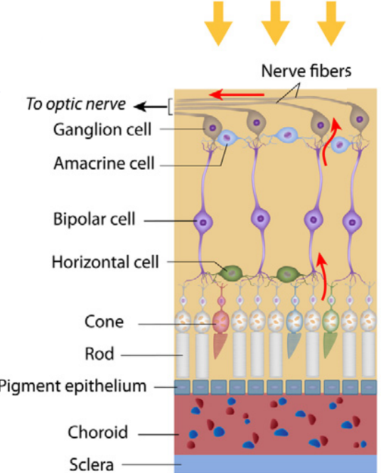Photoreceptors = rods and cones
      * Cones = colored light, works best at relative bright light
      * Rods = peripheral vision, higher sensitivity
        + In dark, rods have Na+ channels open and depolarize $→$ activates bipolar cells $→$ inhibits ganglion cells

Photoreceptors are still firing away while ganglion cells are turned off

* + - * + In light, hyperpolarizes rods $→$ inhibits bipolar cells $→$ activates/excites ganglion cells
      * When dim light, cones shut off
      * Light $→$ passes through cells $→$ hits photoreceptors $→$ photoreceptors transduce light into graded potentials $→$ horizontal + bipolar cells create an image $→$ feed it into ganglion cells
    - Retinal ganglion cell layer
      * Retinal ganglion cell (RGC) is a type of neuron located near inner surface of retina, to receive info from photoreceptors via two intermediate neuron types: bipolar cells and retina amacrine cells
      * Contains axons (no dendrites) that collect at optic disk
      * Does not synapse directly with photoreceptors; goes via bipolar cells
      * Situated eat the anterior (front) of retina
    - Intermediate cell layer
      * Between photoreceptors and ganglion cells
      * Consists of bipolar, horizontal and amacrine cells
      * In fovea (central vision); one-to-one correspondence between photoreceptor (cones) and GC
      * In periphery: 100-to-one correspondence between rods and GC [very concentrated]
    - Bipolar Cells
      * Exist between photoreceptors (rod and cone cells) and GC
      * Transmits signals from photoreceptors to GC
  + Sends difference in variables to the brain
    - Changes in light intensity
    - Differences in contrast

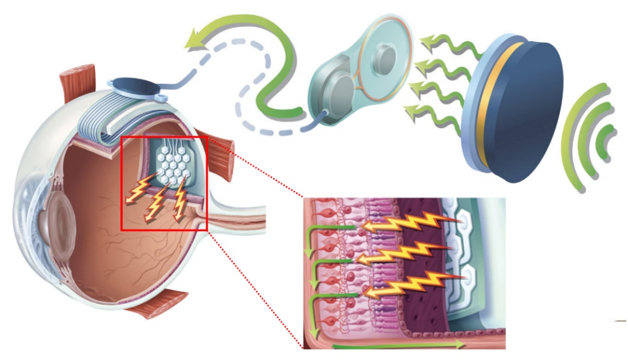PART 3: BIONIC EYE

* During eye degeneration, photoreceptors are lost
* PROBLEM: Create a device that can electrical stimulate ganglion cells to replace lost transduction effects from photoreceptors
  + Only work for some retinal implants
* Retina can be implanted in 3-4 different places
  + Epi-retinal implant = interior front surface of retina
  + Sub-retinal implant = detach retina; slide it behind retina and choroid
  + Subprachoroidal implant = behind choroid/blood supply, further from retina, but simply surgery :D
* REQUIREMENT: needs functioning ganglion cells and optic nerves $→$ not a complete solution for eye defects

HOW DOES BIONIC EYE WORK?

* + External camera/processing system sends radio frequency signals to implanted transmitter behind ear, providing energy and information
  + No implanted battery due to high power consumption
  + Signals = two wires connected to another electronic piece place on top of eye globe exterior
  + Electronic connected to electrode array threaded back of retina (surprachoroidal space)
  + Current passes through electrodes $→$ to choroid $→$ through pigment epithelium $→$ stimulates ganglion cells and possibly bipolar cell $→$ sends signal to optic nerve and visual cortex

DEVICE LONGETIVITY

* + Device coated with a layer of ceramic/platinum/polymer (potentially)/titanium $→$ prevents condensation/leaking/toxicity
  + Titanium lid/ring with ceramic base (Ai oxide)
  + Make it air/water tight
  + Device should last about 50 years

IMPLANT ELECTRONICS

* + 98 channels/sites of neural stimulation $∴$ Charge balanced biphasic current waveform used for safe stimulation
  + Needs chip to stimulate in safe manner
  + 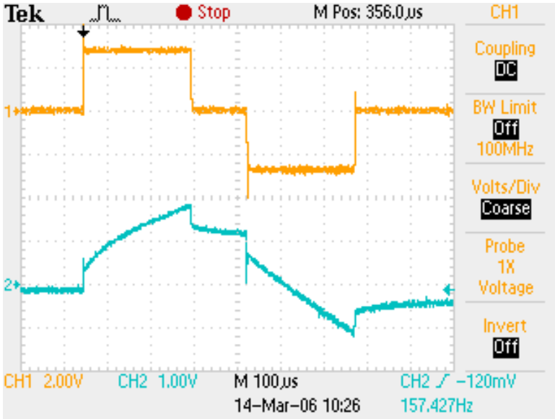When we inject a waveform (area under graph is amount of charged injected) $→$ cells reach threshold and fire action potentials
    - Creates voltage at interface > than at water window
    - Water gets hydrolyzed
    - Electrodes change their pH and dissolve
    - Neural tissue can die off
  + Thus, equal and opposite charge needs to be inject to keep neutrality

SURGICAL PLACEMENT

* + Device sits within stable “pocket”, behind choroid
  + Significantly simplifies surgical approach

Lecture 8 – Monitoring human movement using wearable sensors

PART 1: PHYSICS BEHIND SENSORS AND FUNCTIONALITY

NEWTONS SECOND LAW:

* Accelerometer
* F = ma $→$ How we measure acceleration in systems
* Hooke’s Law : F = -kx
  + Amount of force required to stretch a spring, proportional to the distance needed to be stretched
  + 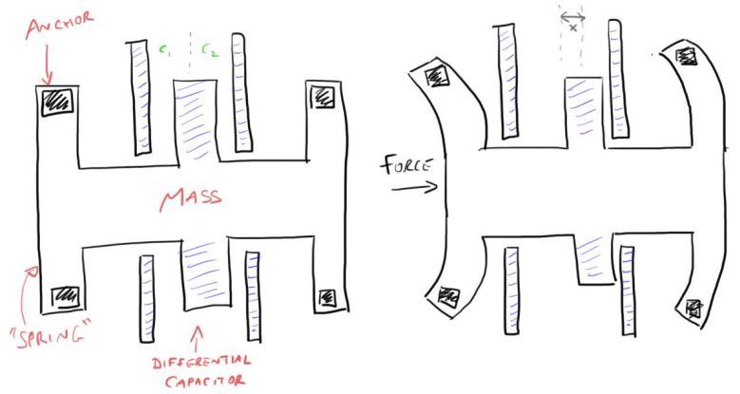If we can measure displacement of the spring, we can figure out the force
  + Spring = beam
    - Force on spring $→$ spring bends $→$ amount of force depends on 2nd law, F = ma (= -kx) $→$ if mass is known, acceleration can be found from displacement (from the bending)
  + Displacement is determined via the different capacitors
    - Different distances from middle plate to outside plate, as well as, relative charges (ie. intensity of attraction)

GYROSCOPES

* Used to determine direction/way of rotation/angular velocity
  + Senses rotation motion + changes in orientation
  + Via change of angle
  + Consists of a wheel or disc that spins rapidly about an axis, with freedom of movement (can change direction)
  + Since orientation of axis is not affected by tilting the mount, it can provide stability or maintain a reference direction in navigation systems, automatic pilots and stabilizers
* 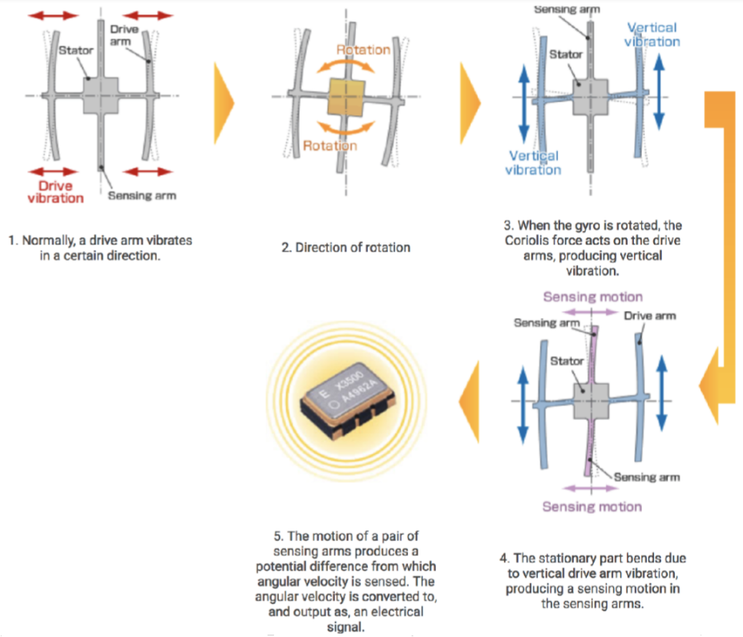Coriolis Effect
  + Pseudo Force effect (force acting on object in rotating frame of reference)
  + Inertial: Acts on objects in motion relative to rotating reference frame
  + Rest Frame: in room
    - Spinning disk in room
    - Put hand over disk and fire a bullet
    - Rotation of disk doesn’t affect bullet’s trajectory; bullet travels straight after being fired
  + Rotational frame: Sitting on disk
    - If hand is put up and a bullet is fired, to me; bullet is going straight up
    - From rest POV, bullet is curving away

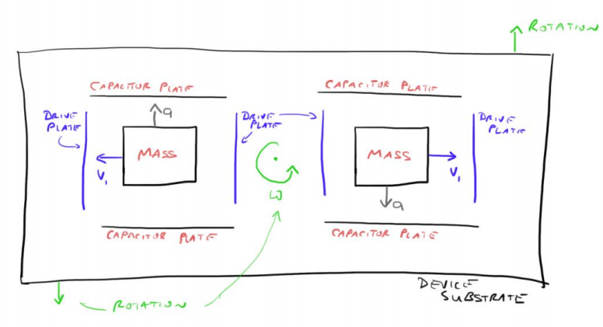MEMS GYROSCOPE

* A differential capacitor (same as accelerometer) to measure displacement
* Mass in capacitor plates shake/vibrate left and right (using coulombs laws) $→$ aka. Vibrating gyroscopes
* But once rotated in any way, coriolis effect takes effect
* 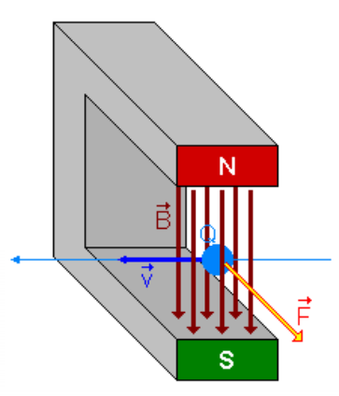When mass moves outward, it accelerates to keep up with the frame. When mass moves to centre, little acceleration needed to keep up with rotation
  + Stationary: mass moves left and right
  + Rotating: mass is deflected up and down
* Can measure displacement for gyroscope via differential capacitor
* Utilizes 2x mass system to keep phone balanced (ie. not vibrate). During movement, mass move perfectly out of phase

MEMS MAGNETOMETER – LORENTZ FORCES

* Easily lost from adding rotations from gyroscopes $→$ magnetometer tells us where we fact
* Lorentz force – if a charged particle is moved with some velocity in a magnetic field, it will feel a force
  + F = V x B (cross product)
  + 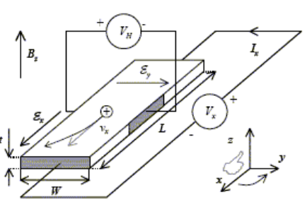Where F is perpendicular (RHPR)
* Application of lorentz force is the hall effect
  + Set up a voltage source, that sends current through a circuit with a s Si semi-conductor (higher resistance than wire, but low enough for current to flow; if current is too high, circuit would explode)
  + Charge moves with velocity $→$ experiences Lorentz forces $→$ charge piles up/pushed to one side of conductor $→$ charge distribution has one side more negative than the other
  + = voltage, indicates presence of magnetic field
  + Needs one in each direction (x,y,z) to detect B-field

ISSUES WITH MEMS MAGNETOMETERS

* 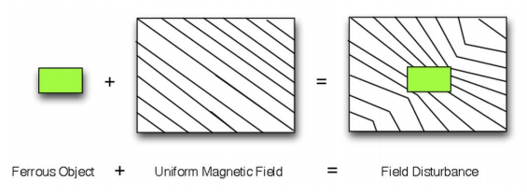Calibration problems $→$ too many magnetic distortions
* Soft Iron = interaction of external field with board
  + Ferromagnetic material on sensor board $→$ material distorts field lines
* Hard iron = fixed magnetic field on board
  + Magnets on sensor board
  + Permanent distortion = always there, always measuring its magnetic field
* Magnetic Declination
  + Earth’s magnetic field is distorted around Earth $→$ compass does not point exactly magnetic north
  + Declination = angle variation on horizontal plane from actual north m
* Magnetic inclination
  + Angle made HORIZONTALLY by Earth’s magnetic field lines
  + At equator, magnetic field goes straight across surface $→$ reliable indication of North
  + South pole = almost 90o

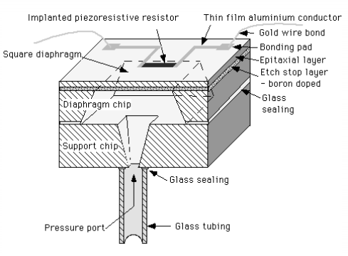MEMS BAROMETER

* Chamber $→$ sealed air inside $→$ implant piece of resistor on diaphragm (thin skin across hull) $→$ resistor changes resistance when stretched
  + As air pressure, outside of chamber, changes, diaphragm:
    - Stretches when moving up, contracts when moving down
    - Measures altitude (but: needs to be calibrated)
    - CONs: pressure changes according to weather (interference)

GPS (Global Positioning System)

* Multilateration; algorithms of distances to determine position
* Needs 4 satellites
  + All satellites contain atomic clocks, synched up (accounting for time delay) $→$ sends signal with time stamp $→$ phone determines distance between satellites from differences in time stamps
* Special relativity slows time for travelling satellites $→$ time delay subtracted

PART 2: MATHS OF ROTATION

* 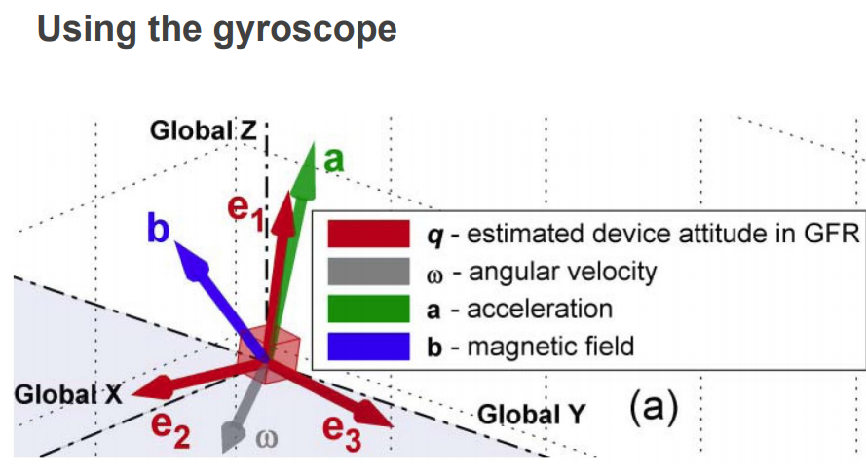Needs to figure out angles between vectors and how to rotate axis angles to determine orientation, given with the data in the gyroscope
* Dot (scalar) product
  + Determines angle between vectors
* Cross (vector) product
  + Finds vector perpendicular to two vectors
* Angular Velocity
  + Angular distance = angle in radians
  + Angle = $\frac{distance along arc }{radius}$
  + Angular velocity = $\frac{angle around axis of rotation}{second}$
    - Speed is perpendicular to $\frac{axis of rotation}{radius }$ [how fast, it is spinning along the arc]

QUATERNIONS

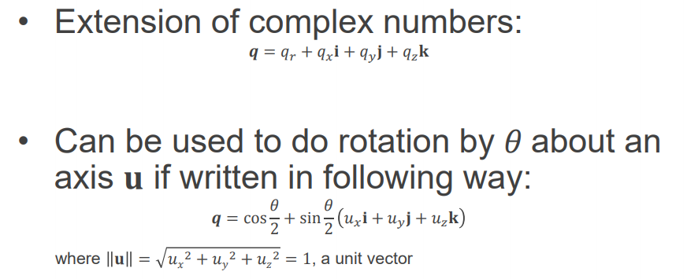

Unit vector can show direction

* Encodes 3D rotation in the word (especially the u-quaternion)

AXIS – ANGLE ROTATIONS = take a point and rotate it around a given vector in 3D space

* + U = rotation axis
    - Needs unit vector form (divide each component by vector’s total absolute length)
  + v and v’ are endpoints of rotation
  + Takes the vector with a ‘0’ real part at front
  + 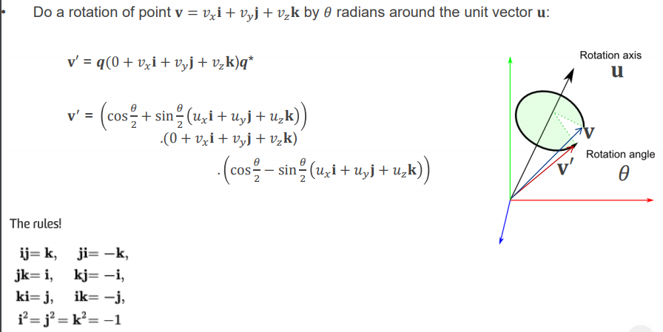Rotation is encoded in q
    - Need to find q and its quaternion conjugate
    - Put it at the start and end = rotation
    - Utilizes the second equation
* Using RH Grip Rule
  + Thumb points in direction of positive z-axis (or axis of rotation)
  + Fingers curl in + $θ$

KALMAN FILTER

= random guess of variables from noisy data (eg. orientations, some angles, progression of data as time progresses)

* 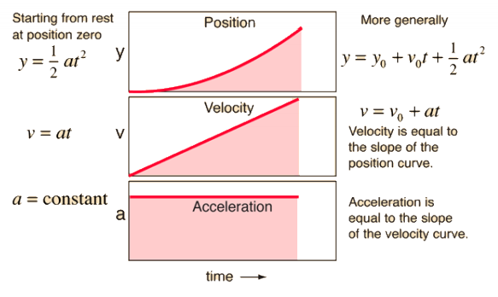Figure out orientation $→$ subtract gravity = just acceleration due to movement
  + Integrate it twice to determine position (although inaccurate, due to unknown constants)

DEAD RECKONING

* Sensor on foot $→$ every time, foot hits ground = 0 velocity $→$ get a trace of vertical vs forward position (x metres)

Lecture 9 – Biomaterials and Tissue Engineering

WHAT IS IT?

* Application of engineering principles and life sciences towards development of biological substitutes to restore, maintain, or improve tissue function or a whole organ
* Creation of new tissue for the therapeutic reconstruction of the human body
* Controls and stimulates target cells by a combination of molecular and mechanical signals, only to manipulate their functionality
* Replace damage or dysfunctional tissue, as well as, an organ replacement

MAIN COMPONENTS REQUIRED IN TISSUE ENGINEERING

* Sample cells from subject/donor; provides building blocks for engineering tissues and organs
* Cell scaffold; provides structure for cells to bind into until cells differentiate into desired tissue/organ
* Signal producers; stimulate growth of cells and their specialization into desire tissues or organs, as well as, ensuring proper functionality of engineered tissue

HOW DOES IT WORK?

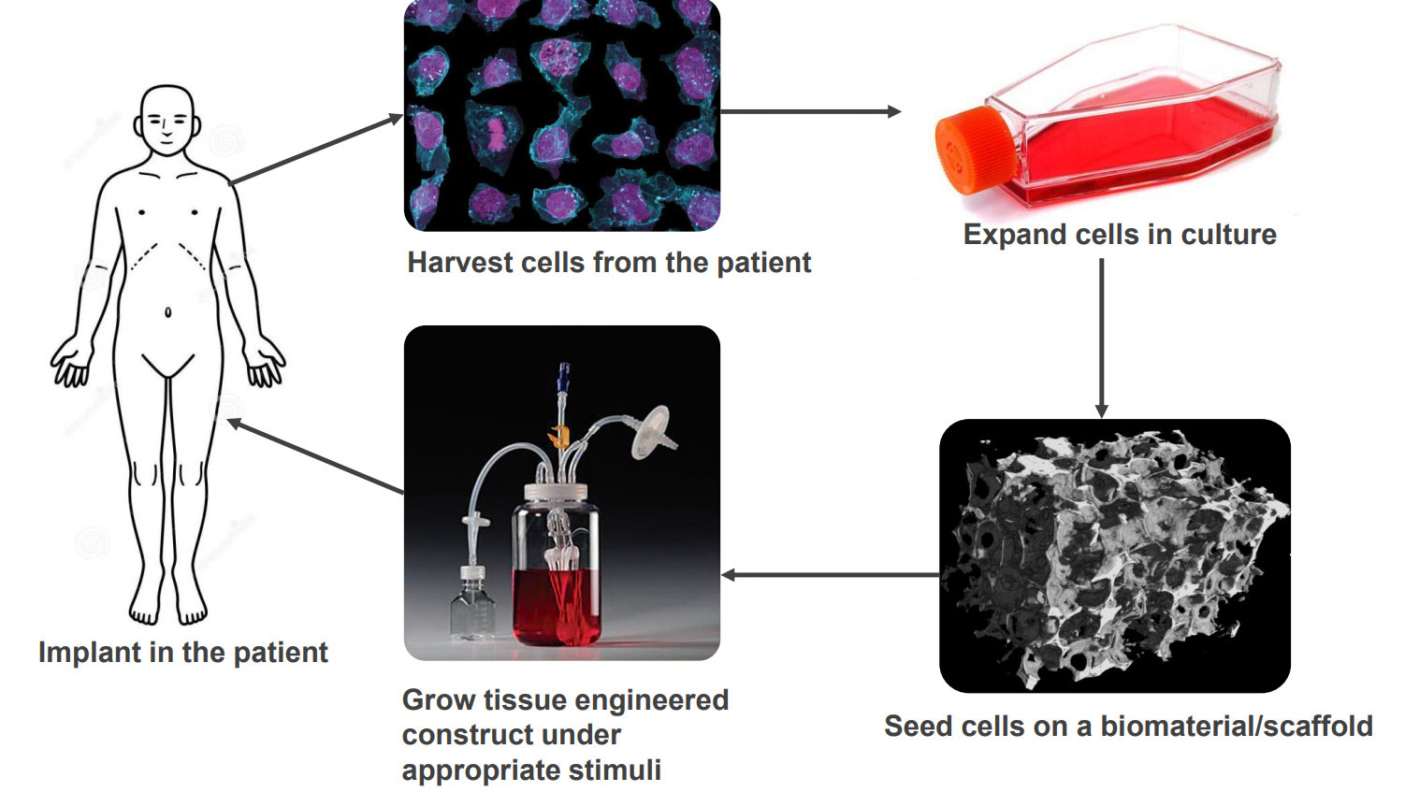

BIOMATERIALS

* 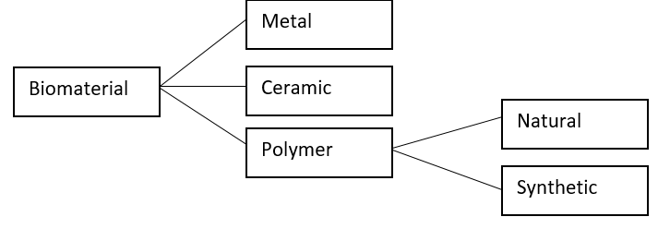‘Material intended to interact with biological systems to evaluate, treat, augment or replace any tissue, organ or body functionality’
* Some examples include; films, sponges, fibres, 3-D printed materials

NATURE VS SYNTHETIC SCAFFOLD MATERIALS

|  |  |
| --- | --- |
| Natural | Synthetic |
| * Ease of binding and architecture of tissue/organ already pre-determined * Since body able to recognize its own collagen cells, additional substances not required to promote binding of cells to scaffold * Hard to separate cells from collagen | * Relatively inexpensive and easier to design and obtain. * Material may be considered foreign to body, immune response may be initiated against the synthetic scaffold * Requires the use of inhibitors or hormones to increase chance of being accepted by a patients’ body. |

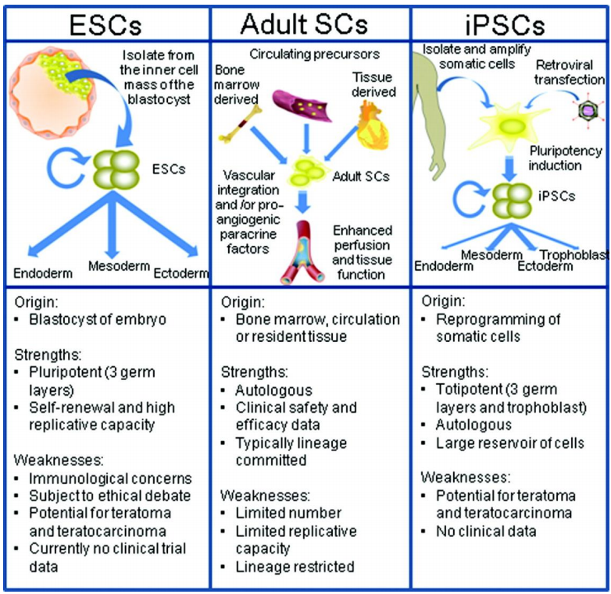CELLS

* ‘An autonomous self-replicating unit that exists as a functional independent unit of life, or a sub-unit of a multicellular organism, only to carry out a particular function towards the organism as a whole’
* Cell culture
  + Cells from various tissue of plants and animals grown and cultured in an artificial environment outside the body
  + Involves:
    - Harvesting of individual cells from specific tissue
    - Maintaining cells in an incubator at body temperature (37oc) in a plastic or glass flask
* Type of cells:
  + Differentiated
  + Stem Cells (seen on right)

DONOR VS PATIENT’S OWN CELLS

|  |  |
| --- | --- |
| Donor | Patient |
| * Allows preservation of patient tissues and organs * Reduces invasiveness towards patients when conducting medical procedures. * Risk of rejection of donor cells once implanted in patient * Lack of suitable donors * Need to screen donors for medical conditions | * Little to no risk of cell rejection by patients’ body * Less processing required to obtain desired function * Limited donor sites to obtain cells and tissues from patient * Risk of infection when extracting tissue from patient, wounds produced during extraction * Underlying patient conditions may make cell extraction difficult/infeasible |

SIGNALS WITHIN TISSUE

* Biochemical, eg. Growth factors
* Mechanical, eg. Strain bioreactor
* Electrical, eg. Electrical stimulation

Lecture 10 – Computational Stimulations in Bioengineering

MODELLING

* Representation of a physical system
  + Formulation of mathematical/computational representation of a physical system
* Can predict behavior of a system
* Typically solve on computer
* In bioengineering $→$ study behavior of complex physiological systems and interactions of external devices
* Examples of modelling:
  + Reading electrical signals from heart pacemakers
  + Electrical stimulation of ganglion cells in vision prosthesis (testing a range of electrical stimulation profiles and how they behave)
  + Electroconvulsive therapy (sending a current through the brain, treats depression, trying to study path of currents through brain and how ECT works)
  + 3D printing by orthopedists when replacing parts
* Used to design electrodes and where to position electrodes

Lecture 11 – Sensory neural prosthesis and transcutaneous energy

FIRST COCHLEAR IMPLANT (1978)

* Electrode array goes into cochlear
* Made from copper coil = inductor
  + Encapsulated in epoxy (may not have been medical grade)
  + Altogether went into electrode array
* Understanding risks:
  + By today’s standards, device would not be commercially marketed/implanted
  + Back in 1978, had a huge demand $→$ advocated for use
  + 2/3 prototypes failed, but since one worked $→$ Cochlear still gained approx. 65% of world market
    - Implanted in > 350,000 people
* 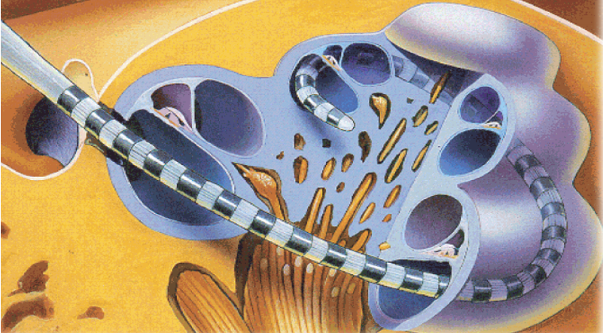Reference to picture (right)
  + Cochlear = bony material
    - Size of tip of pinky
  + Need some material that fits in, loops around and draws out electrical stimulation from electrodes
  + Target tissue = yellow = spiral ganglion cells
    - Collect and form auditory nerve
    - Goes to sound centers of brain to be interpreted
  + Action potential
    - 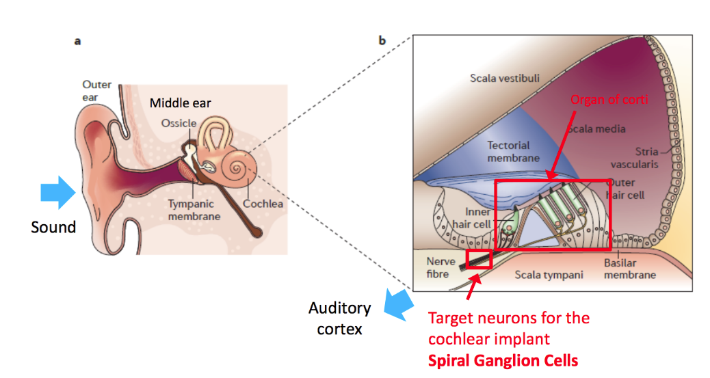Needed to transport signals

ORIGINS OF NEUROMODULATION

* Manipulate cells’ behavior by changing the extracellular potential
* Eg. Applying a voltage relative to the inside of a cell = membrane becomes charged
  + Action potential $→$ enables certain functions in body to occur

SENSORINEURAL HEARING LOSS

* Sound hits the tympanic membrane $→$ vibration
  + Ossicle augments vibration $→$ creates greater mechanical movement on middle ear
  + 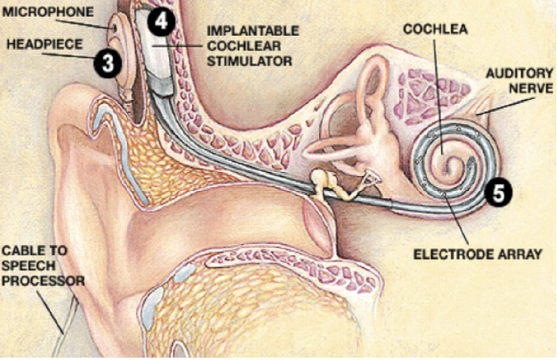Middle ear pushes onto cochlea, moving fluid around $→$ fluid movement bends into inner hair cells $→$ bending generates action potential ∴ sending signals to the brain
  + OCCURS IN THE ORGAN OF CORTI
* Target neurons for implant = spiral ganglion cells
  + Attached to hair cells
  + In diseases (eg. Meningitis) where hair cells are killed $→$ it cannot cause action potential from hair bending
* IF auditory nerve is present and functional, it can be electrically stimulated $→$ can detect sound
* Cochlear implant system
  + Outside = microphone + headpiece
  + 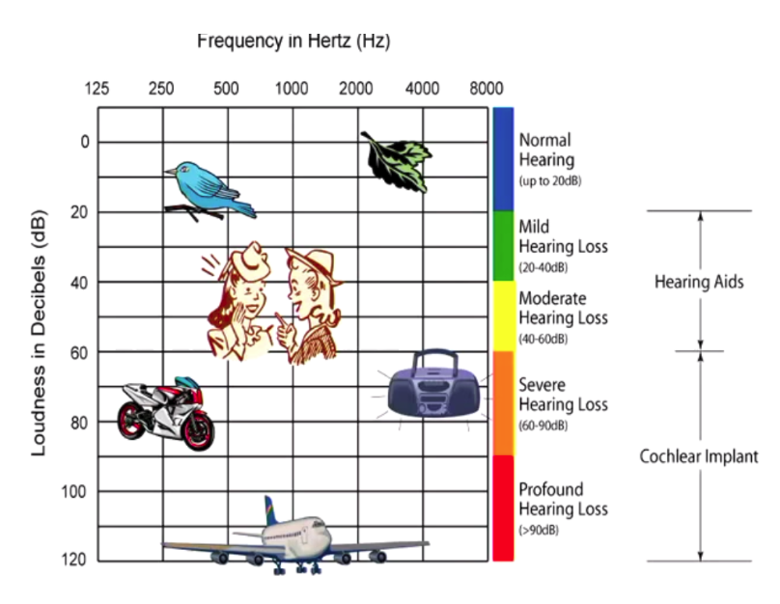Implantable cochlear stimulator $→$ cable $→$ through round window, into cochlear $→$ electrically stimulate various positions of cochlear

THE BIONIC EAR

* Stats:
  + Approx. 120 million are hearing impaired (Approx 1 million in Aus.)
  + 2% are fully deaf $→$ (2.4M worldwide, approx. 20K in Aus.)
  + FDA, initially let Cochlear implant into those profound deaf, as they thought it did more damage than good

THE STIMULUS WAVEFORM

* Use constant current pulses
  + 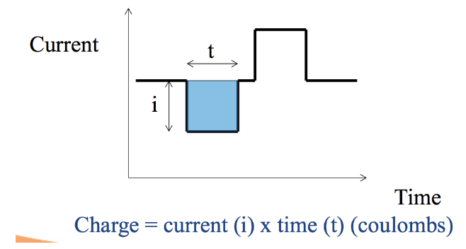 Other devices typically use voltage
* Phase 1 does all the work
  + Gets action potential firing by injecting charge (coulombs)
* Inter-phase gap
  + 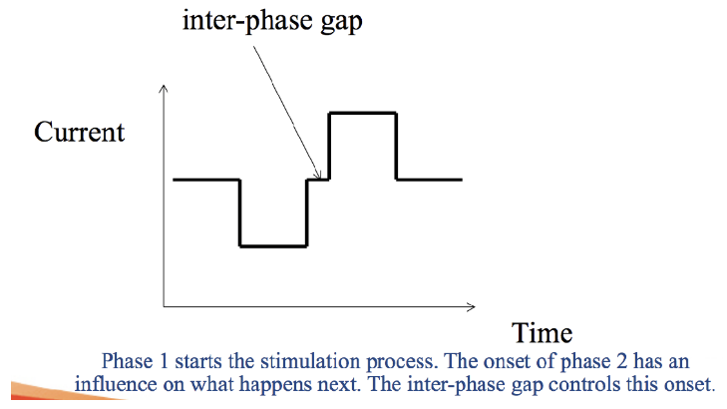Can be adjusted to what is most effective
  + Needed to allow time for action potentials to propagate down to designated area
* Phase 2
  + 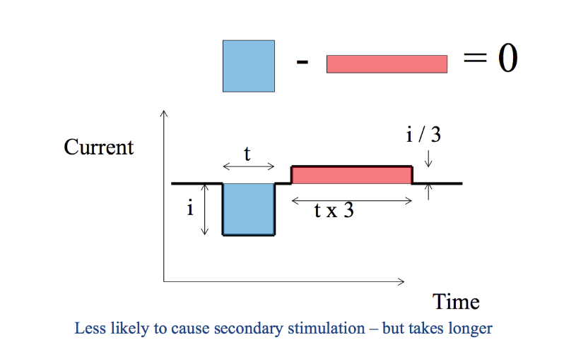Charge recovery = reverse the induced charge and restore neutrality $→$ ear is stimulated again without difficulties arising in electrochemistry
  + Without it, cause buildup of random chemicals and unwanted substances
  + Ideally, has the same amount of charge in second phase
    - But, in reality, not exactly equal due to ions/particles moving away from electrode site
  + Can still cause electrical stimulations
    - Solution: reduce current amplitude but have a pulse occur over a longer amount of time (area = 0)
* Charge = area under curve (sum must = 0, to be neutral)
* Inter-stimulus gap
  + Separation between pulses
  + Limited to how quickly you can feed information, and how quickly the electrodes are serviced
* Stimulation can only occur once at a time
  + Eg. If you have 22 electrodes, only one can be stimulated at a time

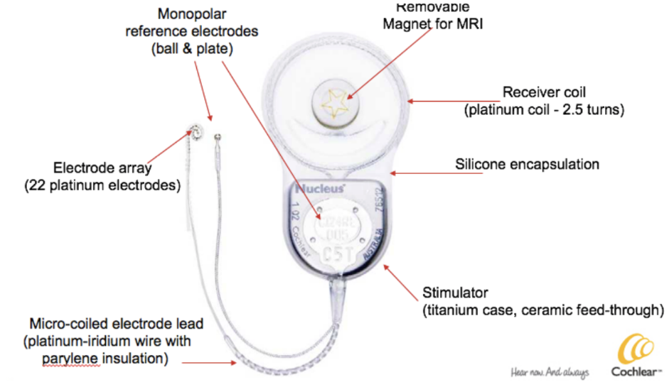NUCLEUS CI24RE

* 24 channels = 22 channels on electrode array + little monopolar reference electrode (ball + plate)
* Monopolar ref. electrodes = return path for the negative return of electrical stimulation
* Contact materials = silicone, titanium and platinum
* All electronics are placed in a little capsule = hermitic chamber
  + Connects to each of little wires
* 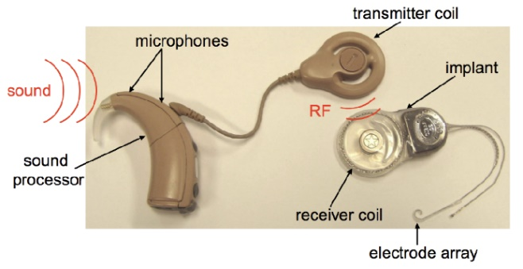Sound processor has 2x microphones
  + Picks up surround sound
  + Assumes most important sound is in front, so sound received = front minus behind sound
  + Sound processor $→$ sends instruction and power to the RF link
* RF link
  + 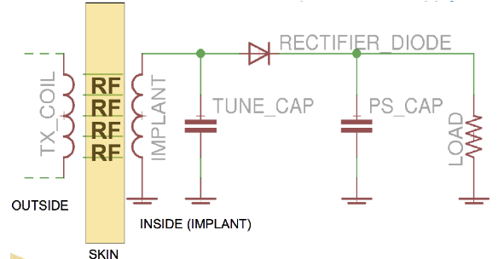Via inductive coupling
  + Outside TX (transmitting) coil $→$ RF signals go through skin $→$ implant (circuitry grabs energy off) $→$ detects when energy is turned on/off
  + Use RF coil to prevent infection from implanting
  + Don’t implant battery (due to big size); coils are very small $→$ allowing babies to wear them

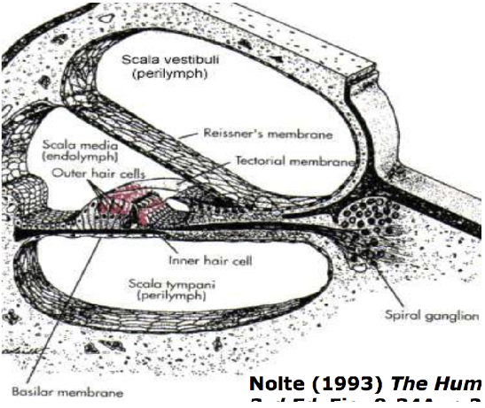ANATOMY OF COCHLEA

* Scala media (media = middle)
* Scala vestibula
* Scala tympani
  + Tympani membrane is where hair cells are excited
  + Target area = spiral ganglion cells
* In picture [right]; electrode array (grey) = metal
  + If e-pulses are emitted from metal, we can excite spiral ganglion cells and send signals off to the brain to be interpreted as sound
* Electrode array
  + 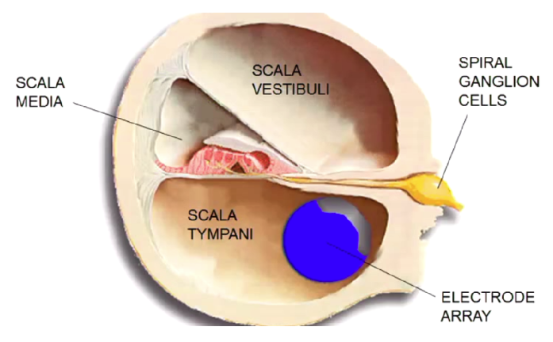Used to be straight, but presently curled
  + Cochlea is curled
  + Allows electrode to get close as possible to spiral ganglion cells
  + Electrical stimuli is directed inside curl of electrode; when it was straight, it will go outside
* BUT: looking at x-ray image, there is still so much of cochlea that isn’t reached
  + Consequences:
    - 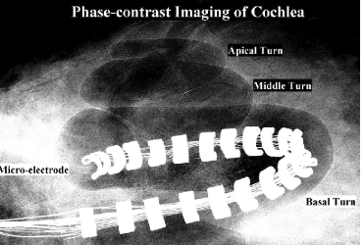Only detecting high pitch/frequency (low frequency = long wavelength penetrating through the deeper end of the cochlea
  + Goal:
    - Have widely spaced electrodes throughout the cochlea
    - Hear all sounds of the spectrum
  + Electrodes are limited to a range of frequencies; not a 1:1 correspondence (eg. Piano keys slammed hard)
  + In 25 years, < 7% of devices have failed